Patterns In Nature
Substances in Tissues
Aim: To identify substances in tissues by using chemical tests.
Method:
Complete the following tests:
- Testing for protein
Place a small amount of substance (4 rice grains) and add a few drops of Biuret solution. Record any colour change.
- Test for Glucose
Place a small amount of substance in a small test tube. Add a few drops of Benedict’s solution and warm gently. Record any colour change.
- Test for starch.
Place a small amount of the sample on a watch glass and add a few drops of iodine solution. Record any colour change.
- Test for Lipids
Obtain a small amount of the sample and rub it onto the brown paper. Allow the paper to dry and record your observations.
- Chloride ions
Place a small amount of sample on a watch glass and add a few drops of silver nitrate solution. Caution – silver nitrate stains both skin and clothing.
- Test for Lignin – see discussion table
Risk Assessment
Risk | Mitigation

Results
Substance | Positive Result (Y/N)

Discussion
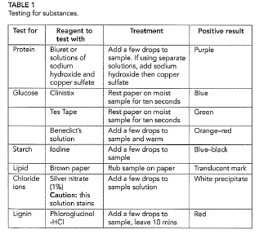
The Biuret solution did not give any positive results, however, when the sodium hydroxide and copper sulfatw were use a purple colour developed and proteins were found in: (list foods that gave a positive result)
Glucose was found in
Starch was found in
Lipids were found in
Chloride ions were found in
The experiment demonstrated that starch was prominently found in plant material. This is because in plants, glucose is converted to starch.
Protein is found in both plant and animal tissue and this was/was not demonstrated by the experiment.

