Patterns In Nature Part 3
Plants and animals have specialised structures to obtain nutrients from their environment
  - identify some examples that demonstrate the structural and functional relationships between cells, tissues, organs and organ systems in multicellular organisms
  - In multicellular organisms, different cells can become specialised to perform different functions.
  - Multicellular organisms are made up of many cells.
  - CELLS are the smallest unit of life. They perform specific functions:
    - E.g. muscle cell - its job is to contract or relax
  - TISSUES are groups of cells with similar functions. They perform functions as a group of cells:
    - E.g. muscle tissue - made up of muscle cells, job is to contract or relax
  - ORGANS are made up of groups of tissues that function as a whole:
    - E.g. the stomach - made of muscle tissues, is moves to churn food
  - ORGAN SYSTEMS are groups of organs that function together as a coordinated system to perform a role for the body
    - E.g. digestive system - made up of organs such as the stomach

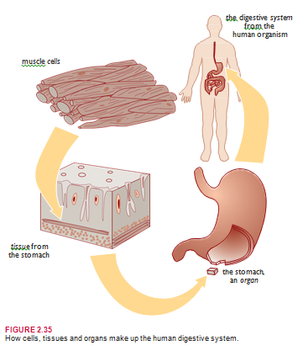

  - distinguish between autotrophs and heterotrophs in terms of nutrient requirements
  - Autotrophic means ‘self-feeding’. Autotrophs are organisms that make their own food through photosynthesis:
    - Nutrient requirements: Autotrophs, such as plants, require the substances necessary for photosynthesis. These are water, carbon dioxide and sunlight. They also need oxygen and sugars for respiration
  - Heterotrophs are organisms that consume other organisms for nutrition:
    - Nutrient requirements: Heterotrophs require other organisms to feed on, such as how herbivores eat plants, and carnivores eat meat. They also need oxygen for respiration and water for life.

  - identify the materials required for photosynthesis and its role in ecosystems
  - Photosynthesis is the process by which plants create glucose
  - This synthesis of organic compounds from inorganic compounds is a process all living things ultimately depend on.
  - Plants make food through photosynthesis, herbivores eat plants, carnivores eat herbivores, and the food chain continues. However, they all begin with plants
  - The materials needed for photosynthesis are water, CO2, and chlorophyll

- identify the general word equation for photosynthesis and outline this as a summary of a chain of biochemical reactions
  - The general word equation for photosynthesis is:
Carbon dioxide + Water ⎯⎯SUN⎯LIG⎯HT−⎯And⎯−CH⎯LOR⎯OPH⎯Y⎯LL → Sugar and Oxygen
  - The chemical equation for photosynthesis is:
6CO2 + 12H2O C6H12O6 + 6O2 + 6H2O

Photosynthesis is thought to occur in two stages:
Light Reactions of Photosynthesis:
      - Only this stage requires sunlight
      - Light absorbed by chloroplasts is used to split water molecules
      - This process is called photolysis
      - In this process, the water molecule is split into oxygen and hydrogen
      - This process occurs on the thylakoids of chloroplasts
Light-Independent Reactions of Photosynthesis:
      - Also called the carbon-fixation stage
      - Hydrogen released from the first reaction is joined with carbon dioxide to form sugars
      - This process requires energy

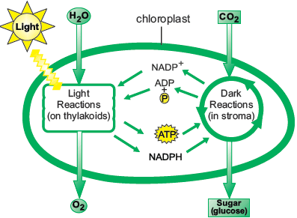

- explain the relationship between the organisation of the structures used to obtain water and minerals in a range of plants and the need to increase the surface area available for absorption
Obtaining water and minerals:
    - In aquatic environments, water and minerals are absorbed across the whole surface of the plants
    - However, for terrestrial (land) plants, water and minerals are obtained through root systems Root systems must have a very large surface area to absorb enough nutrients for the whole plant
    - They achieve this through having a branching structure and many root hairs
    - The root system can also be used to anchor the plant
    - Many different types of root systems exist
Different types of roots used to absorb nutrients are:
      - TAP ROOTS: These types of root systems have one main root, called the tap root, from which side roots come out from. Tap roots many penetrate deeply into the soil. Sometimes the taproots act as storage organs and swell up, such as carrots.
      - FIBROUS ROOTS: These root systems form networks of roots close to the soil surface. They can spread out widely to support the plant, and provide a large surface area for absorption of mineral ions and water
      - MYCORRHIZA: This is where the root system is associated with fungi in a symbiotic relationship. The fungi provides the plants with additional mineral nutrients and the plant provides carbon based products for the fungi
      - AERIAL ROOTS: In areas like water logged estuaries or swamps, plants produce roots that grow above the ground. These roots help with gas exchange

External Root Structure:
      - The root system of a plant is usually below the ground
      - Roots do not photosynthesise, and do not have leaves or buds
      - The growing points of roots are protected by root caps
      - As roots grow throughout the soil they branch out and provide a large surface area for absorption as well as an anchor for the plant
      - Most of the absorption occurs in the root hairs of the root

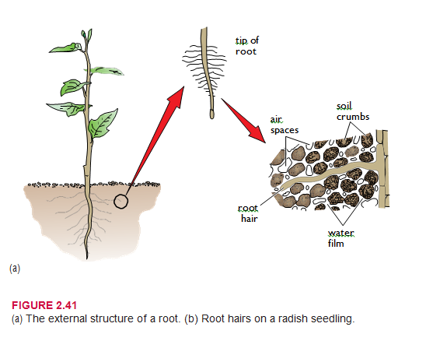
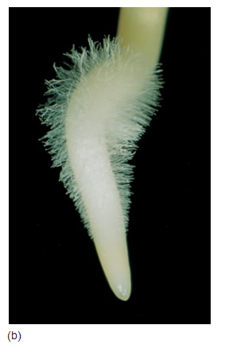
Internal Root Structure:
      - The basic root structure is made up of the three parts: the epidermis, the cortex and the vascular tissue
      - Epidermis: The outer layer of the root. It lacks a cuticle. In young roots, the epidermis is covered with a slimy coating or sheath called mucigel
      - Cortex: The cortex is in between the epidermis and the vascular tissue. It acts as a storage area for excess materials, and has air spaces for gas flow
      - Vascular Tissue: In roots, it forms a cylinder in the centre. It is made of xylem and phloem vessels. It transports water and nutrients
- Vascular tissue In roots the vascular tissue forms a cylinder in the centre. It consists of xylem and phloem, and is some- times called the stele.
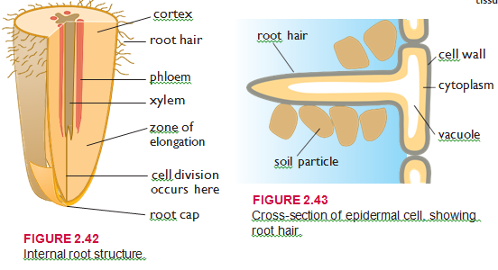

- explain the relationship between the shape of leaves, the distribution of tissues in them and their role
Obtaining sunlight and carbon dioxide:
    - The specialised leaf structure of the plant used for obtaining light and carbon dioxide is the leaf
    - Most of the photosynthesis of plants occurs in leaves
    - The lamina is the blade of the leaf
    - The petiole is the part that attaches it to the stem

External Leaf Structure:
      - Arrangement: Leaves are usually arranged along the stems in a way that exposes them to the maximum amount of sunlight. They are usually positioned so that sunlight strikes the upper part of the leaf.
      - Shape: Most leaves are broad, thin and flat. This gives them a large surface area for the capture of sunlight and gas exchange needed for photosynthesis and respiration.
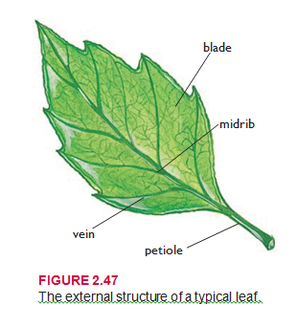

Internal Leaf Structure:
      - Cuticle: This is a waxy layer over the surface of the leaf. It is waterproof and provides shape and protection. It plays an important part in reducing water loss in terrestrial plants
      - Epidermis: It is a single protective layer of cells on the upper and lower side of leaves. It is transparent to allow light to pass through.
      - Stomates: These are pores in the leaf that can open and close. When open, they allow gas exchange, but this results in water loss.
      - Mesophyll: Mesophyll are the cells in the middle of the cell, in between the upper epidermis and lower epidermis. There are two types:
        - Palisade Mesophyll: They are regularly arranged, elongated and packed with chloroplasts. Most of the photosynthesis occurs in these cells.
        - Spongy Mesophyll: Situated under the palisade, but above the lower epidermis. Contains less chloroplasts, and are randomly arranged with large air spaces to allow gas exchange.

      - Veins: Veins are tubes of vascular tissue in plants. They form a branching network in the leaves, providing structure and shape. Vascular tissue:
        - XYLEM: Transports water and minerals from roots to leaves
        - PHLOEM: Transports products of photosynthesis to the rest of plant

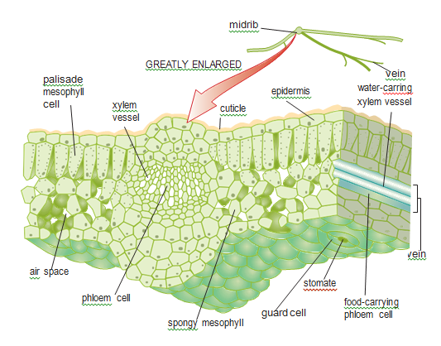

- describe the role of teeth in increasing the surface area of complex foods for exposure to digestive chemicals
  - Animals are heterotrophic; they get nourishment from the external environment
  - The digestive system is the system responsible for breaking down food to a size where they can be used by cells
  - There are two parts of digestion:
    - Mechanical Digestion:
      - This involves breaking food down through mechanical means.
      - The teeth are the most important means of mechanical digestion.
      - The role of teeth is to break food down into smaller pieces to increase the surface area of the food.
      - The greater the surface area, the better the digestive chemicals can act on the food.
      - The stomach is also involved with mechanical digestion.

    - Chemical digestion:
      - This involves the use of enzymes to chemically break food down.
      - Amylases - enzyme that acts on carbohydrates.
      - Proteases - enzyme that acts on proteins.
      - Lipases - enzyme that acts on lipids.

- explain the relationship between the length and overall complexity of digestive systems of a vertebrate herbivore and a vertebrate carnivore with respect to:
  - the chemical composition of their diet
  - the functions of the structures involved
Herbivores:
    - The main component of a herbivore’s diet is plant material
    - Most of the mass of plant material is made up of cellulose
    - They have flat teeth to grind the fibrous plant material
    - Plant material is difficult to breakdown compared to animal material
    - Herbivores use the help of micro-organisms to help digest the cellulose
    - This digestion can occur in two places:
      - FORE-GUT FERMENTERS: This type of herbivore (e.g. cows) digests their food in a chamber before the stomach called the rumen
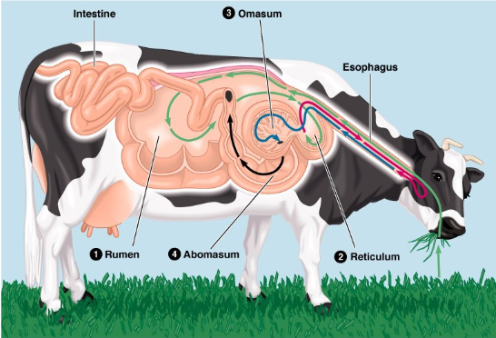

      - HIND-GUT FERMENTERS: This type of herbivore (e.g. horses) digests its food in a chamber after the small intestine called the caecum.
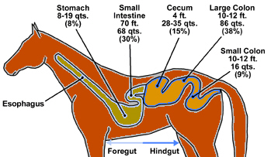

    - Compared to meat, plant material is low in energy
    - Plants also take longer and is harder to digest than meat
    - This means that herbivores have to constantly eat to survive
    - The digestive systems of herbivores are a lot larger and longer than that of carnivores. This is because plants take longer to digest

Carnivores:
    - The main component of their diet is meat
    - Meat is high in energy, and is relatively easy to digest
    - This means that the digestive systems of carnivores are short compared to herbivores and also have to specialised organs like the caecum or rumen
    - They have very short large intestines, as the meat has already been absorbed in the small intestine
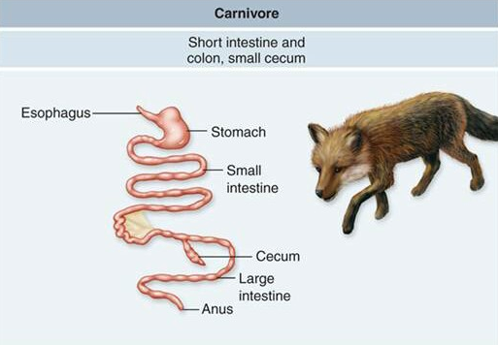

  - plan, choose equipment or resources and perform first-hand investigations to gather information and use available evidence to demonstrate the need for chlorophyll and light in photosynthesis

- perform a first-hand investigation to demonstrate the relationship between surface area and rate of reaction

- identify data sources, gather, process, analyse and present information from secondary sources and use available evidence to compare the digestive systems of mammals, including a grazing herbivore, carnivore and a predominantly nectar feeding animal

