Patterns In Nature

Part 2

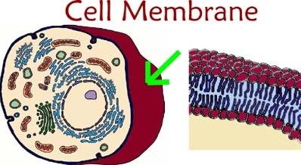

Membranes around cells provide separation from and links with the external environment

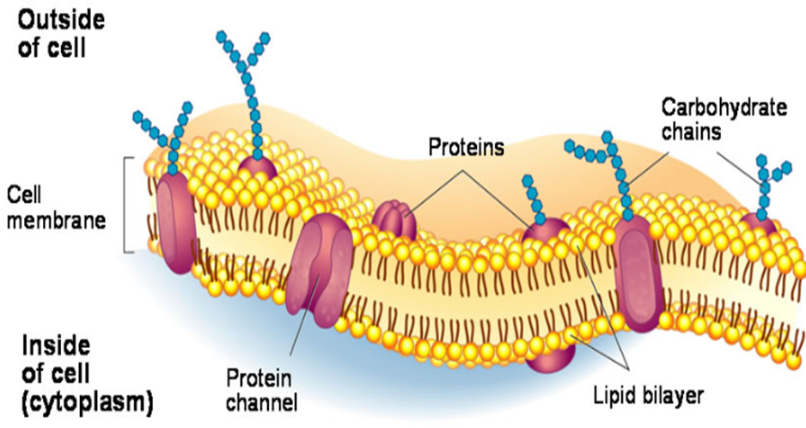

- identify the major groups of substances found in living cells and their uses in cell activities

Organic molecules contain carbon. Most inorganic molecules don’t
Inorganic substances in the body:
    - Water: The most abundant inorganic substance in the body. 70% of the body’s molecules are water. Most reactions in cells require water. Nutrients and wastes are carried around in water. It has many other uses in the body.
    - Oxygen gas: Used to release energy in the body
    - Salts: These are usually in the form of ions, such as chlorides, phosphates and sulfates of various metals. Their uses include:
      - Calcium Ion: Builds bones, teeth, helps blood clot and proper nerve and muscle functions.
      - Iron Ion: Carries oxygen in red blood cells.
      - Phosphate Ion: Part of the energy carrier ATP. Also part of nuclei acids.
      - Sodium Ion: Functioning of nerves.
Organic Substances in the body include:
    - Carbohydrates: Compounds composed of C, H and O. The number of hydrogens is always double the number of oxygen.
      - USES: An energy source in cells; also used in structure in plants (cellulose)
      - The three groups of carbohydrates are monosaccharides, disaccharides and polysaccharides.
      - Monosaccharides are the simplest carbs. They consist of only one unit of sugar. Examples are glucose, fructose and ribose. Monosaccharides are the basic building blocks of more complex carbohydrates.
      - Disaccharides are simple carbohydrates composed of 2 units of sugar. An example is sucrose (table sugar) made of glucose and fructose.
      - Polysaccharides are complex carbohydrates made up of many sugar units joint into a huge molecule. An example is starch, which is a food store in plants. One starch molecule is made of 2000-3000 glucose molecules.
    - Lipids: They are compounds made of the same elements as carbohydrates; that is, carbon, hydrogen, and oxygen. There is usually very little oxygen in lipids. They have more than twice the energy of carbohydrates.
      - USES: Used as stores of energy, used as water-proof coating on leaves, makes up part of the cell membrane.
    - Proteins: Proteins consist of carbon, hydrogen, oxygen and nitrogen (C, H, O and N).
      - USES: Needed for growth and repair, make up a major part of the body’s structure. Vital to the structure and function of cells. Are essential for metabolism (all chemical reactions in cells) as enzymes are made up of proteins.
      - Made up of long chains of amino acids, joined together by peptide bonds
      - There are 20 different amino acids
      - The 3D shape of a protein determines which amino acids are on the outside of the protein, and this determines the protein’s characteristics
      - When a protein is heated, the structure changes, and the protein’s behaviour and characteristics are changed
    - Nucleic Acids: Are made up of carbon, hydrogen, oxygen, nitrogen and phosphorus (C, H, O, N and P). They include DNA and RNA
      - USES: They determine heredity in organisms. Is needed for the manufacture of proteins.
      - Are made up of groups of nucleotides; a nucleotide is made up of a nitrogen base, a pentose sugar and a phosphate
      - Deoxyribonucleic Acid (DNA) is mostly found in chromosomes
      - Ribonucleic Acid (RNA) is found throughout the cell
      - DNA contains deoxyribose sugar. RNA contains ribose

- identify that there is movement of molecules into and out of cells
  - Every cell is surrounded by the cell (or plasma) membrane.
  - The cell membrane regulates the flow of substances in and out of the cell. It is differentially or selectively permeable
  - Molecules are continually moving in and out of cells
  - Raw materials are needed and wastes need to be expelled
  - The cell continually exchanges materials with its external environment

- describe the current model of membrane structure and explain how it accounts for the movement of some substances into and out of cells
  - Every cell is surrounded by a cell membrane (or plasma membrane)
  - This membrane regulates what enters or leaves the cell
  - The cell membrane is differentially permeable; i.e. only certain substances can cross over it.
  - Cell membranes can form, reform and change and appear very dynamic
  - The cell membrane is 40% lipid and 60% protein
  - The current model of the cell membrane is the FLUID MOSAIC MODEL:
- According to the model, the cell membrane is a thin sheet composed of 2 layers (a bilayer) of special lipids called phospholipids
- The bilayer is very fluid and the lipids can move about easily
- Other lipids such as cholesterol are also found in it.
- Proteins are scattered throughout the membrane. They are of 2 types:
- Integral proteins: they go through both layers and come out on both sides
- Peripheral proteins: attached to the integral proteins inside or outside
  - The way that this model accounts for substances moving in and out of cells is as follows:
    - Passive Transport: This is movement of substances across that membrane that requires no energy. This includes:

      - Diffusion: This involves the diffusion of substances, such as water and oxygen, through the membrane, from high to low concentration. The substances diffuse right through the phospholipid layers
      - Facilitated Diffusion: This involves the diffusion of substances into the cell, but not directly through the phospholipid layer. These substances diffuse through integral proteins in the cell membrane.
Active Transport:
- Molecules cannot pass through the cell membrane at times because of their properties; eg they may be too large, they may be stopped by the diffusion gradient, they carry electrical charges, etc. In active transport, specific carrier proteins bind to these molecules and bring them inside the cell. This requires the use of energy. Endocytosis is a form of active transport where large molecules are transported across a membrane. 3 types of endocytosis include:
      - Pinocytosis: The material being transported is a liquid
      - Phagocytosis: The material being transported is a solid
      - Receptor Mediated Endocytosis: The molecules bind to specific receptor sites in the membrane called coated pits.

- compare the processes of diffusion and osmosis
Diffusion
- A diffusion gradient exists whenever two areas have different concentrations of a substance; the substance moves until the two concentrations are equal.
- This requires no energy.
- Movement requiring no energy is known as passive transport.
- Water, oxygen, carbon dioxide and other small ions and molecules can diffuse freely through cell membranes.
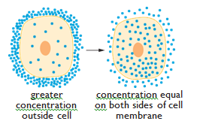
Osmosis

- Osmosis is a special case of passive transport involving the diffusion of water molecules across a selectively permeable membrane.
- Water will move by diffusion from an area where there is more of it to an area where there is less of it.
- This results in the movement of water from a dilute (less concentrated) solution to a stronger (more concentrated) solution.
- It is the way that water enters or leaves cells.

Diffusion | Osmosis
Involves random movement of particles | Involves random movement of particles
Movement of substance from high concentration to low concentration | Movement of substance from high concentration to low concentration
Requires no energy | Requires no energy
Does not need to involve a differentially permeable membrane | Always involves a differentially permeable membrane
Involves liquids and gases | Involves only water
https://www.youtube.com/watch?v=OXCKjhE1xco

- explain how the surface area to volume ratio affects the rate of movement of substances into and out of cells

  - Cells obtains their nutrients through their cell membranes
  - The surface area of the membrane has to fulfill the requirements of the whole volume of the cell.
  - If the cell becomes larger, the surface area to volume ratio becomes smaller, and the surface area of the cell membrane is not enough to fulfill the needs of the whole cell.
  - This places a restriction on the size of cells.
  - If the surface area to volume ratio is large, movement of substances is efficient
  - If surface area to volume ratio is small, movement of substances is slow and inefficient, and is not enough for the cell.
  - This is how SA:V affects the movement of substances in and out of cells.

