Hsc biology

Module 5

heredity

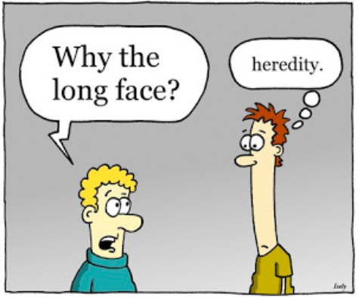

Reproduction
Inquiry question: How does reproduction ensure the continuity of a species?

- explain the mechanisms of reproduction that ensure the continuity of a species, by analysing sexual and asexual methods of reproduction in a variety of organisms, including but not limited to:
  - animals: advantages of external and internal fertilisation
  - plants: asexual and sexual reproduction
  - fungi: budding, spores
  - bacteria: binary fission
  - protists: binary fission, budding

- Reproduction is fundamental to the continuity of life.
- To achieve this organisms must live to maturity and produce fertile offspring.
- Reproductive success is the feature of an individual while biological fitness is a feature of an allele in a population.

- There are 2 main methods of reproduction:
- Asexual – only one parent that produces identical offspring
- Sexual – two parents with the offspring having a mix of the parents genes and hence, differ from each other and their parents.

- advantages of external and internal fertilisation
- Advantages of External and Internal Fertilisation
  - Fertilisation is the process by which the male and female gametes fuse to form a diploid zygote.
  - Conditions needed for fertilisation:
  - Both male and female gametes need to be produced and ready at same time
  - Arrangements need to be bring the gametes in contact with each other
  - Water needs to be present (male gametes must swim to the female gamete)

- External Fertilisation:
    - Fertilisation takes place outside the body
    - Most aquatic animals have external fertilisation
    - Male and female gametes are shot into the water in the hope of fertilisation
    - To ensure fertilisation, millions of gametes are released
    - The chances of fertilisation are increased because:
- Cyclical reproductive behaviours
- Synchronised timing of gamete production and release
- The development of courtship and mating behaviours in animals

- External Fertilisation in Animals
- Staghorn Coral
- Although corals can reproduce internally, they're able to practice external fertilization, too. When corals spawn, a huge amount of gametes are released into the water. Only a very small proportion of the eggs released will be fertilized by sperm, but it's still enough to keep coral numbers up. Once the fertilized eggs have hatched, the coral larvae head up to the surface to mature, after which they sink back down to the rocky seabed to find a place to anchor themselves.
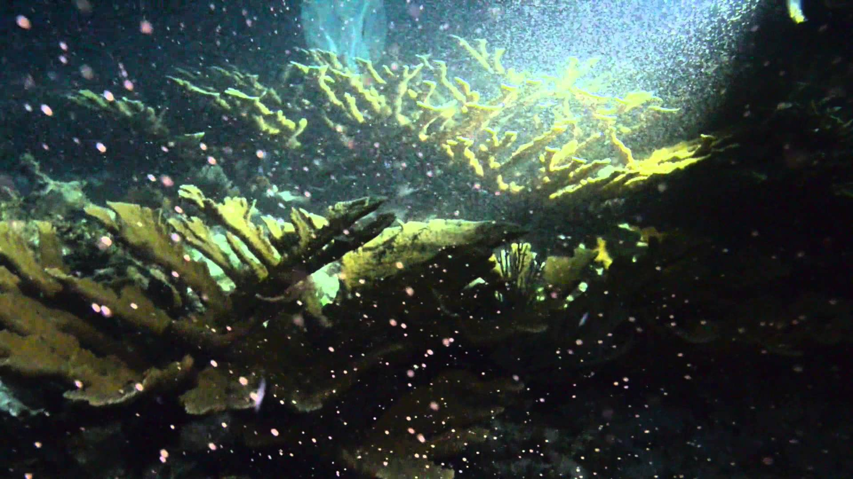

- Bony Fish
- Salmon Spawning
At two to seven years old, salmon are ready to spawn. Some salmon lay eggs only once and other species spawn many times. In the fall, mature salmon change colour, and return from the ocean to the spawning beds from where they were hatched. The process begins with the female digging a hole in the gravel with her tail. A female salmon will lay a few thousand eggs in the hole that will be fertilised by the male fish when it releases its sperm.

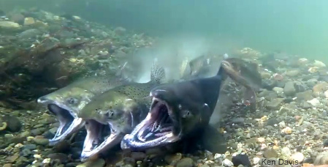

Comparison of Internal and External fertilisation
Take notes from videos
____________________________________________________________________________________________________________________________________________________________________________________________________________________________________________________________________________________________________________________________________________________________________________________________________________________________________________________________________________________________________________________________________________________________________________________________________________________________________________________________________________________________________________________________________________________________________________________________________________________________________________________________________________________________________________________________________________________________________________________________________________________________________________________________________________________________________________________________________________________________________________________________________________________________________________________________________________________________________________________________________________________________________________________________________________________________________________________________________________________________________________________________________________________________________________________________________________________________________________________________________________________________________________________________________________________________________________________

- Internal Fertilisation in Animals
- Animals that undergo internal fertilisation tend to live in terrestrial environments.
The internal environment for fertilisation:
- Fewer eggs are produced
- Protects gametes from dehydration
- Protects against loss to external elements
- Protects fertilised eggs and developing young from predation

- The internally fertilised egg may develop a shell and be laid in an external environment (oviparous) to complete its development, (birds reptiles etc), or it may continue to develop internally.

- Mammals
- Mammals are divided into three sub-classes:
  - Monotremes
  - Marsupials
  - Eutherians

- Eutherians
- Eutherians include most mammals for example dogs, cat’s rabbits and humans.
- In most mammals the fertilised egg becomes an embryo that is nurtured inside the female’s body and receives nutrients through the mother’s placenta and is born alive.
- The fertilised egg implants into the uterine wall a placenta develops delivering nutrients and oxygen through the placenta to the developing embryo. Wastes are removed through these organs.

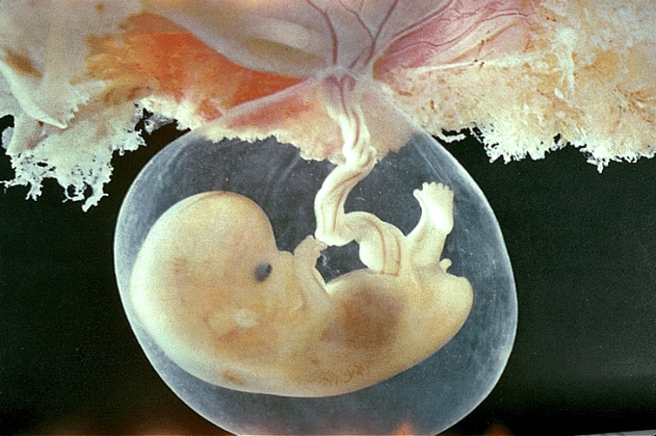

Other Mammals
- Monotremes:
- Monotremes include the platypus and the echidna which are oviparous (lay eggs).
- Fertilisation is internal.
- The platypus incubate their eggs in a nest while the echidna places them into an abdominal pouch where remain for about 7 weeks. Hatchling obtain milk from the mother’s mammary glands.
- The kangaroo undergoes internal fertilisation but it can have 3 offspring at different stages of development.
- One out of the pouch but still drinking milk
- One in the pouch attached to a nipple
- A fertilised ovum at the blastocyst (ball of cells) stage – embryonic diapause

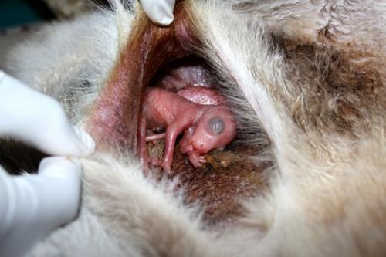

- Other Animals
- Birds
- Birds are oviparous - they undergo internal fertilisation and lay eggs

- Reptiles
- Reptiles are fertilised internally and eggs are externally to the mother’s body.
- Ovo-vivparous
- An exception to this are the ovo-viviparous, (some snakes and sharks) who keep eggs with yolk for nourishment inside the mother’s body until they are ready to be born alive.

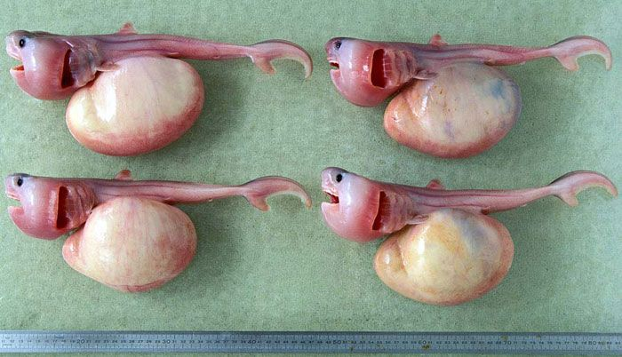

- Sea horses (Family: Syngnathidae) are ovo-vivparous but it is the male seahorse that holds the eggs.
- The female seahorse deposits the eggs into a pouch on the male.
- The male releases sperm into the pouch, fertilising the eggs.
- After the embryos have developed, the male gives birth to tiny seahorses.
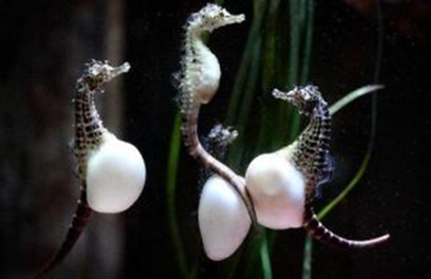
Male seahorses
- plants: asexual and sexual reproduction
Alternation of generations – sexual and asexual reproduction
- Some mechanisms of asexual reproduction include:
  - Binary Fission: Every time a single celled organism under goes mitosis, it creates 2 new organisms.
  - Spore Formation: Fungi reproduce asexually by producing thousands of single-celled spores. These will germinate if the conditions are right. A type of plant (ferns) also produces spores.
  - Budding: The parent produces a replica of itself by mitosis. This replica continues to grow as a new organism, but is attached to the parent. This tends to form large colonies, such as coral
  - Vegetative Propagation: Flowering plants produce new plants from points on roots or stems called nodes. Grasses do this.

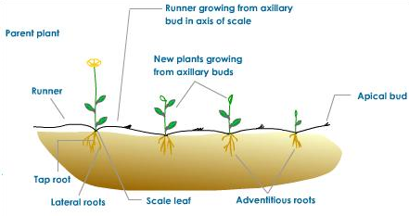
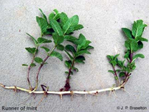

  - Regeneration: It is a process that organisms grow back body parts that have been removed or lost. In some cases, it can be a form of asexual reproduction, of the broken body part grows to form a new organism.

- Flowers
- Flowers are the reproductive organs of angiosperm plants
- Flowers are protected in the bud by sepals (usually petal-like)
- Petals surround the male and female reproductive organs
  - Male reproductive organ:
    - Called the stamen
    - Made of anther and filament
    - Meiosis occurs in anther and produces pollen grains
    - Pollen grains have a thick outer layer and 2 haploid nuclei
  - Female reproductive organ:
    - Called the pistil; made up of a number of carpels
    - Each carpel is made of a stigma, style and ovary
    - Meiosis occurs in the ovules, which are in the ovary

  - Pollination and Fertilisation:
    - Pollination is the transfer of pollen onto a mature stigma
    - Fertilisation occurs after pollination, in the following way:
    - The pollen on the stigma sends a pollen tube down the style to the ovary
    - The two haploid nuclei of the pollen grain travel down the tube. One of the nuclei become the nucleus of the new tube cell, while the other nucleus divides again and they both travel down the tube to the ovule
    - The pollen tube enters the ovule through a tiny hole called the micropyle
    - One of the nuclei fuses with the ovum to form the zygote

  - Self-pollination involved pollen going on to the stigma of the same plant

  - Cross-pollination involves pollen falling on the stigma of different plants

  - 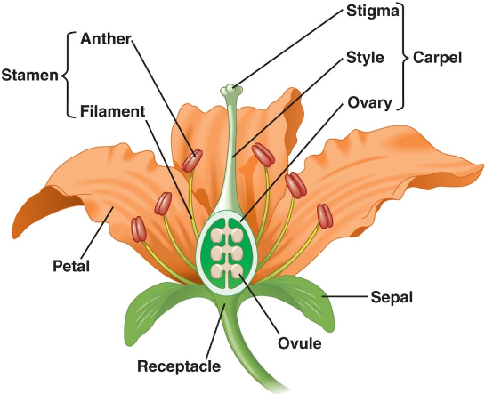

- Examples of pollination in Australian plants:

Australian Plant | Method of Pollination | Adaptations of Flower
Wattle | Wind | Large masses of pollen produced - can be carried over many kilometres by wind. Pollen is produced in such large quantities so higher chances of landing on stigma of another flower.
Bottlebrush | Birds | Spectacular bright red flowers attract birds  Birds visit flower for nectar, pollen attaches to their bodies and is spread from flower to flower
Melaleuca | Bat | Strong smelling flower, thick nectar, dull flowers
Grevillea | Parrot | Produces lots of nectar; no petals, just masses of stamens
Heath Banksia | Possums | Produces a lot of nectars food supply for possums.  No petals
Australian Orchid | Wasp | It flowers and matures during wasp’s breeding season Releases scent similar to female wasp, and flowers similar to female wasp, so as the male tries to mate, pollen rubs off.

- Seed dispersal is the spreading of seeds away from the parent plant. Advantages of seed dispersal are:
  - Species are more likely to survive dangers such as disease, fire, or environmental change if the seeds are covering a very widespread area. If the seeds are not spread, the entire population can get wiped-out in one go
  - Decrease in competition for space, light, or nutrients. Less competition from parent plant, or plants from same generation.

- Examples of seed dispersal in Australian plants:
Australian Plant | Type of Dispersall | Adaptations
Feather spear grass | Wind | Seeds attached to fine hairs which float in the breeze Seeds can be carried hundreds of kilometres kkkkilometreskilometres
Sheep’s Burr | Animal | Seeds have hooks that attach to the fur of animals, and are carried over large distances
Acacia’s Native  Raspberry | Ants | The ants carry the fruit away to the nest, but the seed  is covered in a coating the ant can’t eat.

- Fungi: budding
  - Budding, in biology, a form of asexual reproduction in which a new individual develops from some generative anatomical point of the parent organism.
  - In some species buds may be produced from almost any point of the body, but in many cases budding is restricted to specialized areas.
  - The initial protuberance of proliferating cytoplasm or cells, the bud, eventually develops into an organism duplicating the parent.
  - The new individual may separate to exist independently, or the buds may remain attached, forming aggregates or colonies.

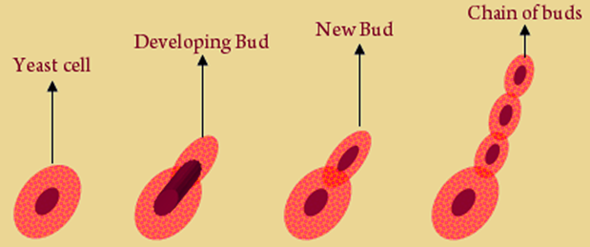

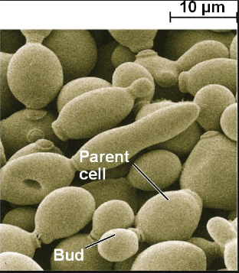

  - Fungi spores
- Fungal spores are microscopic biological particles that allow fungi to be reproduced, serving a similar purpose to that of seeds in the plant world.
- Spores are reproductive bodies that are the result of asexual reproduction.

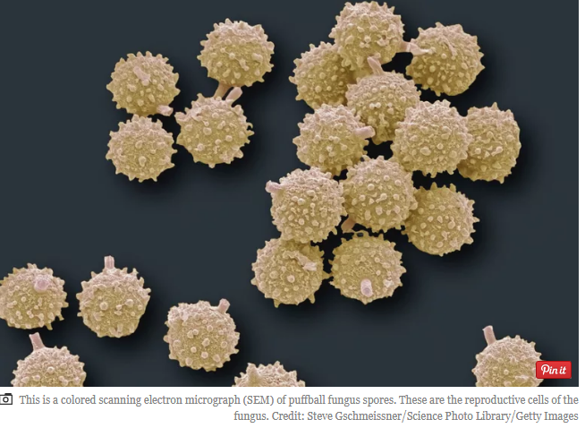

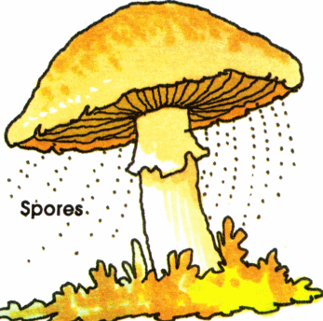

- bacteria: binary fission
- Bacteria reproduce by binary fission.
- Binary fission begins when the DNA of the bacterium divides into two (replicates). The bacterial cell then elongates and splits into two daughter cells each with identical DNA to the parent cell. Each daughter cell is a clone of the parent cell.

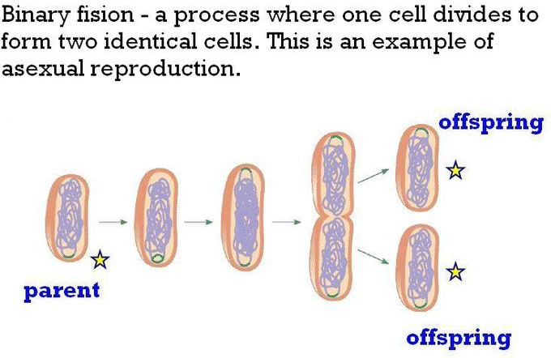

- protists: binary fission, budding
- Protists are a diverse collection of organisms: algae, amoebas, ciliates and paramecium.
- While exceptions exist, they are primarily microscopic and unicellular, or made up of a single cell.
- The cells of protists are highly organized with a nucleus and specialized cellular machinery called organelles.
- Asexual reproduction is the most common among protists. Protists can reproduce asexually through binary fission, one nucleus divides; multiple fission, many nuclei divide; and budding.
- Budding occurs when a new organism grows from the body of its parent.

- Binary fission in protists

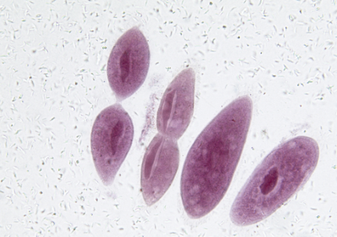

- analyse the features of fertilisation, implantation and hormonal control of pregnancy and birth in mammals

- Sexual reproduction in mammals requires fertilisation.
- This is where two gametes (sperm and the egg) combine to form a gamete.
- Mammals have reproductive strategies to maximise the reproductive success:
- internal fertilisation
- implantation of the embryo into the uterine wall with internal development of the embryo
- pregnancy to allow the developing young to be protected from the external environment and to have a constant nutrient supply.
- All the stages are synchronised by a combination of hormones.

- The human male and female reproductive cycles are controlled by the interaction of hormones from the hypothalamus and anterior pituitary with hormones from reproductive tissues and organs.

- In both sexes, the hypothalamus monitors and causes the release of hormones from the pituitary gland. When the reproductive hormone is required, the hypothalamus sends a gonadotropin-releasing hormone (GnRH) to the anterior pituitary.

- This causes the release of follicle stimulating hormone (FSH) (Follicle stimulating hormone is one of the hormones essential to pubertal development and the function of women’s ovaries and men’s testes) and luteinizing hormone (LH) from the anterior pituitary into the blood. This hormone is crucial to ensuring a healthy reproductive system. It is produced and released in the anterior pituitary gland and is responsible in controlling the function of ovaries in females and testes in males.

- Male Hormones
- At the onset of puberty, the hypothalamus causes the release of FSH and LH into the male system for the first time. FSH enters the testes and stimulates the Sertoli cells to begin facilitating spermatogenesis using negative feedback, as illustrated in
Figure 24.14. LH also enters the testes and stimulates the interstitial cells of Leydig to make and release testosterone into the testes and the blood.
- Testosterone, the hormone responsible for the secondary sexual characteristics that develop in the male during adolescence, stimulates spermatogenesis.

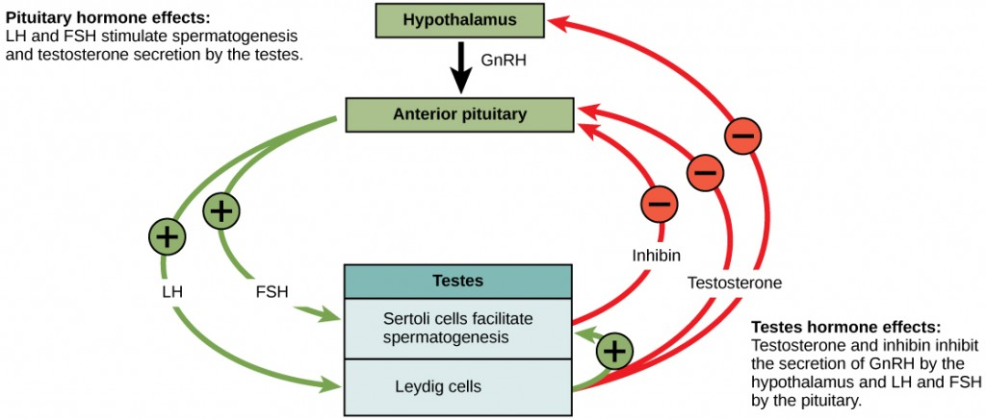
Figure 24.14. Hormones control sperm production in a negative feedback system.

- A negative feedback system occurs in the male with rising levels of testosterone acting on the hypothalamus and anterior pituitary to inhibit the release of GnRH, FSH, and LH.
- The Sertoli cells produce the hormone inhibin, which is released into the blood when the sperm count is too high. This inhibits the release of GnRH and FSH, which will cause spermatogenesis to slow down.
- If the sperm count reaches 20 million/ml, the Sertoli cells cease the release of inhibin, and the sperm count increases.

- Female Hormones

- The control of reproduction in females is more complex. As with the male, the anterior pituitary hormones cause the release of the hormones FSH and LH.
- In addition, estrogens and progesterone are released from the developing follicles.
- Estrogen is the reproductive hormone in females that assists in endometrial regrowth, ovulation, and calcium absorption.
- Progesterone assists in endometrial re-growth and inhibition of FSH and LH release.
- In females, FSH stimulates development of egg cells, called ova, which develop in structures called follicles.
- Follicle cells produce the hormone inhibin, which inhibits FSH production. LH also plays a role in the development of ova, induction of ovulation, and stimulation of estradiol and progesterone production by the ovaries.
- Estradiol and progesterone are steroid hormones that prepare the body for pregnancy. Both estradiol and progesterone regulate the menstrual cycle.

- The Ovarian Cycle and the Menstrual Cycle
  - The ovarian cycle governs the preparation of endocrine tissues and release of eggs, while the menstrual cycle governs the preparation and maintenance of the uterine lining. These cycles occur concurrently and are coordinated over a 22–32 day cycle, with an average length of 28 days.
  - The first half of the ovarian cycle is the follicular phase shown in Figure 24.15. Slowly rising levels of FSH and LH cause the growth of follicles on the surface of the ovary. This process prepares the egg for ovulation.
  - As the follicles grow, they begin releasing estrogens and a low level of progesterone. Progesterone maintains the endometrium to help ensure pregnancy.

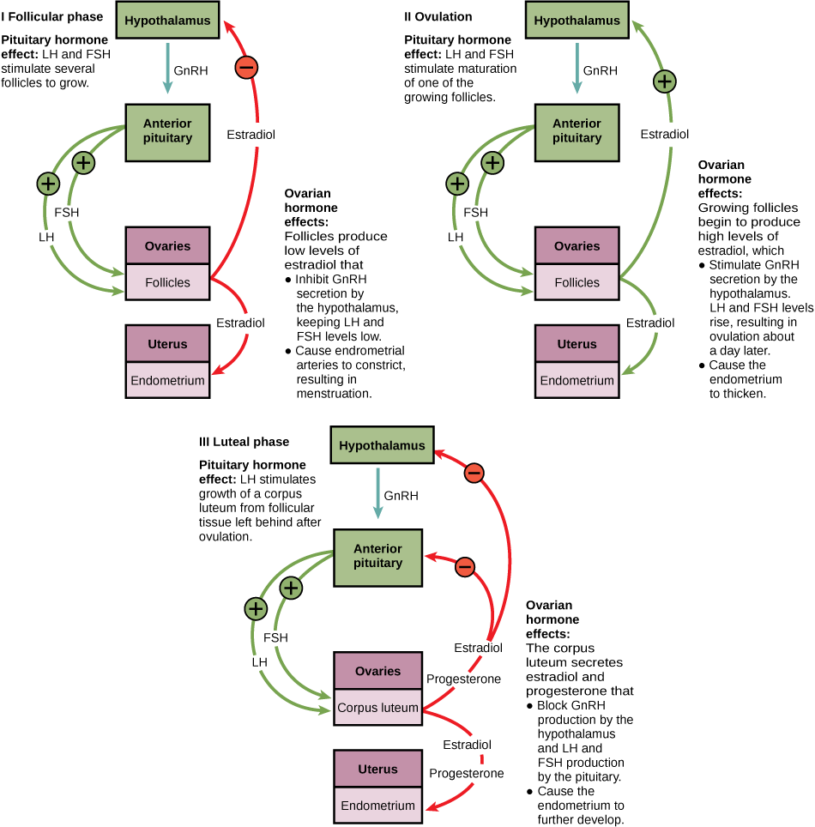
Figure 24.15. The ovarian and menstrual cycles of female reproduction are regulated by hormones produced by the hypothalamus, pituitary, and ovaries.

- Just prior to the middle of the cycle (approximately day 14), the high level of estrogen causes FSH and especially LH to rise rapidly, then fall. The spike in LH causes ovulation: the most mature follicle, like that shown in Figure 24.16, ruptures and releases its egg. The follicles that did not rupture degenerate and their eggs are lost. The level of estrogen decreases when the extra follicles degenerate.
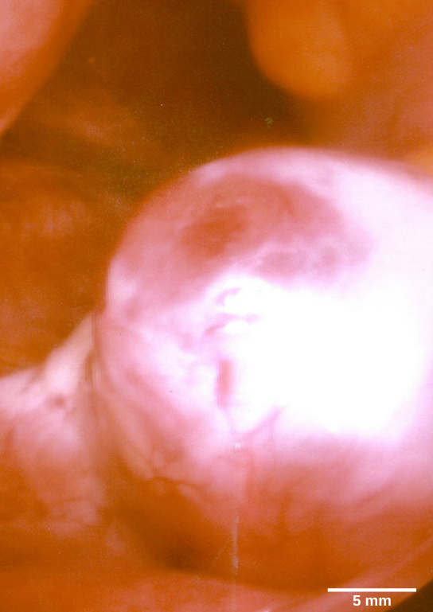
Figure 24.16. This mature egg follicle may rupture and release an egg. (credit: scale-bar data from Matt Russell)
- Following ovulation, the ovarian cycle enters its luteal phase, illustrated in Figure 24.15 and the menstrual cycle enters its secretory phase, both of which run from about day 15 to 28.
- The luteal and secretory phases refer to changes in the ruptured follicle. The cells in the follicle undergo physical changes and produce a structure called a corpus luteum. The corpus luteum produces estrogen and progesterone.
- The progesterone facilitates the regrowth of the uterine lining and inhibits the release of further FSH and LH. The uterus is being prepared to accept a fertilized egg, should it occur during this cycle.
- The inhibition of FSH and LH prevents any further eggs and follicles from developing, while the progesterone is elevated. The level of estrogen produced by the corpus luteum increases to a steady level for the next few days.
- If no fertilized egg is implanted into the uterus, the corpus luteum degenerates and the levels of estrogen and progesterone decrease. The endometrium begins to degenerate as the progesterone levels drop, initiating the next menstrual cycle.
- The decrease in progesterone also allows the hypothalamus to send GnRH to the anterior pituitary, releasing FSH and LH and starting the cycles again. Figure 24.17 visually compares the ovarian and uterine cycles as well as the commensurate hormone levels.

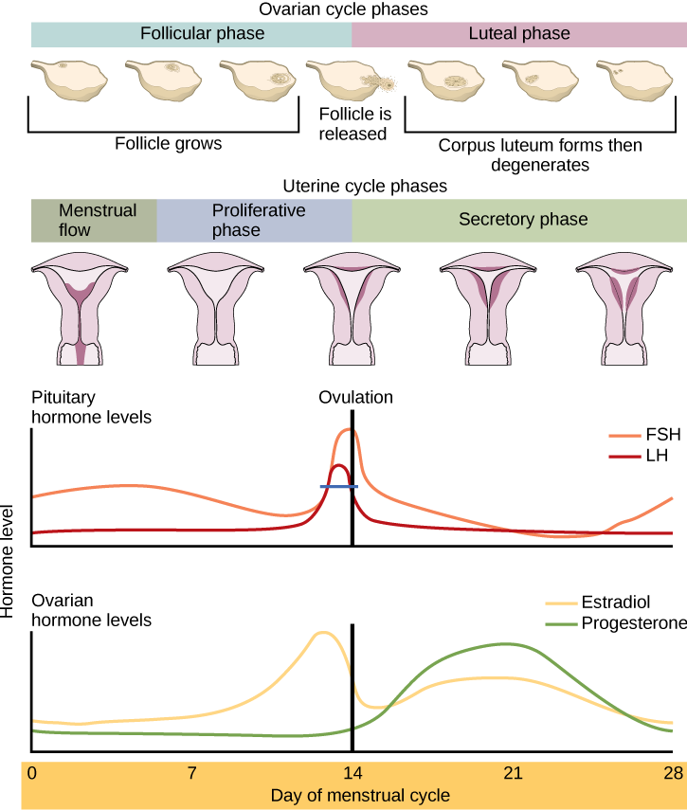
Figure 24.17. Rising and falling hormone levels result in progression of the ovarian and menstrual cycles. (credit: modification of work by Mikael Häggström)

- The Role of Birth Hormones
- Birth hormones are chemical “messengers” that your body makes. Your baby makes birth hormones, too. These hormones work together to guide important changes in your bodies — changes that help make labour and birth go smoothly and safely for both of you.
- Four hormones that are important for reproduction: oxytocin, endorphins, adrenaline and related stress hormones, and prolactin. These hormones play a major role in regulating labour and birth.
- Oxytocin
- Oxytocin is involved with fertility, contractions during labour and birth and the release of milk in breastfeeding.
- Receptor cells that allow your body to respond to oxytocin increase gradually in pregnancy and then increase a lot during labour.
- Oxytocin stimulates powerful contractions that help to thin and open (dilate) the cervix, move the baby down and out of the birth canal, push out the placenta, and limit bleeding at the site of the placenta.
- During labour and birth, the pressure of the baby against your cervix, and then against tissues in the pelvic floor, stimulates oxytocin and contractions. So does a breastfeeding newborn.

- Endorphins
- When you face stress or pain, your body produces calming and pain-relieving hormones called endorphins. You may have higher levels of endorphins near the end of pregnancy.
- For women who don’t use pain medication during labour, the level of endorphins continues to rise steadily and steeply through the birth of the baby.
- High endorphin levels during labour and birth can produce an altered state of consciousness that can help you deal with the process of giving birth, even if it is long and challenging.
- Low levels of endorphins can cause problems in labour and birth by:
- Causing labour to be excessively painful and difficult to tolerate.

- Adrenaline
- Adrenaline is the "fight or flight" hormone that humans produce to help ensure survival.
- Women who feel threatened during labour (for example, by fear or severe pain) may produce high levels of adrenaline. Adrenaline can slow labour or stop it altogether.
- Too much adrenaline can cause problems in labour and birth by:
- Causing distress to the baby before birth.
- Causing contractions to stop, slow or have an erratic pattern, and lengthening labour.
- Prolactin
- It increases during pregnancy and peaks when labour starts on its own.
- Continued prolactin production during and after labour appears to be readying a woman’s body for breastfeeding.
- Prolactin is central to breast milk production.
- Low levels of prolactin may cause problems through:
- Poorer transition of the baby at the time of birth.
- Poorer growth and development of the baby.

- evaluate the impact of scientific knowledge on the manipulation of plant and animal reproduction in agriculture

Reproductive technologies

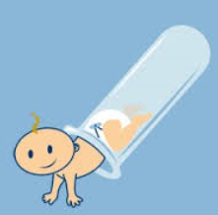

Current reproductive technologies and genetic engineering have the potential to alter the path of evolution
- Background Information
Reproductive technologies include artificial insemination, artificial pollination and cloning. Genetic engineering aims to move genetic material (usually single genes) from one organism and introduce it into the genetic complement of another, thus producing a transgenic organism, (donating to an organism DNA from an unrelated organism which is artificially introduced). The technologies together have meant that the process of natural selection no longer dictates the direction of evolution. Indeed, genes are now moving across species barriers. This brings the possibility of improved crop and livestock yields to feed starving populations, as well as a possible end to the suffering of people with incurable genetic diseases. This technology also has its critics who feel that the new transgenic species could bring with them unforeseen ecological and medical disasters.
In the case of all the technologies mentioned, the donor gametes or body cells have been carefully selected for predetermined characteristics – or artificially selected. In most cases, one exemplary donor contributes all the genetic material and this results in uniform offspring. Over generations, genetic variability within the species has been reduced.

- Current reproductive techniques and how they may alter the genetic composition of a population
- Current reproductive technologies include Artificial Insemination, Artificial pollination and cloning.
- With these techniques, humans can artificially create genetic variations, therefore, altering the genotype and phenotype of an organism.

- Artificial Insemination
- This requires fertilisation, but not mating. Sperm from a desirable male is transferred to a female through an artificial insemination process.

- Also, IVF (In Vitro Fertilisation) is an artificial reproductive technology, in which the fertilisation of the ovum takes place outside the body. The fertilised egg is then implanted back into the uterus, where it develops. This process is also used in agricultural breeding of horses and cows.
- This process allows for genes that may not have been passed on naturally, to be passed on, thus altering the genetic composition of a population.
- Sperm is collected from the male and inserted into the female’s vagina for fertilisation to occur.
- Increases the chance that the sperm fertilises the egg.
- Advantageous in situations where it is costly or difficult to bring the male and female together or if natural conception cannot occur. For example, Sperm from a good bull in England can be collected and transported to Australia to artificially inseminate a chosen cow.

- Possible biological disadvantages because if some sperm are more desirable than others, this can:
- Reduce genetic variation and diversity in a population.
- Create an imbalance of sexes in the population as couples can determine the gender of the unborn child prior to fertilisation.
- Reduces the chances of random crosses in the population and thus reduce genetic variability within the population.

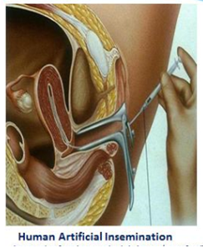

- Artificial Pollination
- This requires fertilisation. Pollen from a selected plant breed with desirable traits is transferred to the female stigma.
- This creates a new hybrid species, and so alters the genetic composition of a population.
- This usually results in a reduction of plant species biodiversity, because unwanted characteristics are ‘bred out’.
- Plants are bred with selected characteristics.
- Pollen form the male anther is usually brushed onto the female stigma.
- The pollinated flower is covered to ensure that pollination from other flowers does not occur.
- If plants are bred with the same set of similar desirable characteristics, the genetic diversity of the population is reduced.

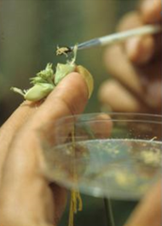

- Cloning
- This does not require fertilisation.
Animal and plant cloning refers to the making of genetically identical organisms, asexually from single cells.
- It is usually carried out through one of two processes:
- DNA is extracted from the organism’s tissue and inserted into an egg which has its own DNA removed, thus creating an embryo
- Cells are taken from an embryo and allowed to develop into several embryos with identical genes.
- Cloning produces populations of animals that are genetically identical to each other. The advantage of this is that characteristics can be precisely controlled and organisms can be produced in short periods of time, however the population is less likely to survive sudden environmental changes.
Dolly the Sheep
  - Dolly the sheep was cloned by Scottish scientists led by Wilmut in 1996.
  - Originated from an udder cell of an adult ewe.
  - Process used is called nuclear transfer technique. Two types of cells are cultured in this process; recipient (egg) and donor (body) cells.
  - The chromosomes are removed from the egg.
  - The donor cell is already specialised and only some of its genes are active. The cell must be returned to its’ non-specialised, embryonic state for all genes to be active.
  - Next, the specialised cell was placed in a salt solution which deprived it of the nutrients it needed and caused the cell to forget its specialisation.
  - An electric jolt was used to fuse the donor and recipient cells and thus start cell division.
  - Once the cell mass formed it was implanted into the surrogate sheep’s uterus.
  - The egg cell and the donor nucleus developed into a sheep that was genetically identical to its parent.
  - Dolly the Sheep died of lung cancer at the age of six.
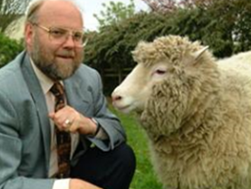

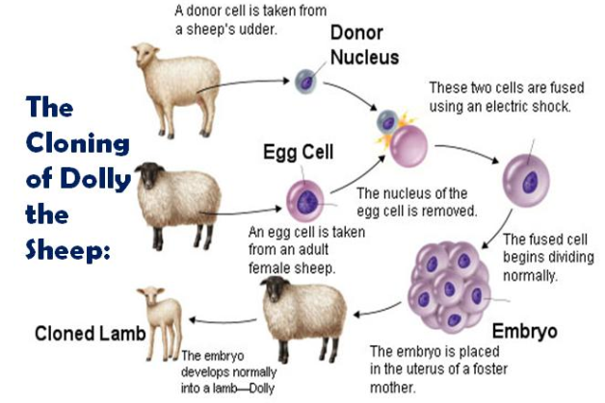

Cell Replication
Inquiry question: How important is it for genetic material to be replicated exactly?

- model the processes involved in cell replication, including but not limited to:
  - mitosis and meiosis
  - DNA replication using the Watson and Crick DNA model, including nucleotide composition, pairing and bonding
- assess the effect of the cell replication processes on the continuity of species

- Mitosis:
    - Cell division, where two daughter cells are produced that are identical to the parent cell.
    - It is used for growth and repair
    - Also basis of sexual reproduction
    - Division occurs only once
    - Genetic stability
    - The stages are Interphase, Prophase, Metaphase, Anaphase and Telophase
    - Cells produced are diploid (identical number of chromosomes to parent)

- Meiosis:
- Cell division that produces 4 cells with half the number of chromosomes compared to the parent cell, (haploid).

- Phases of meiosis
    - These cells are sex-cells; also called gametes
    - Gametes are either male or female; produced by both genders
    - Gametes fuse together during fertilisation to form a zygote, which multiplies by mitosis to form a new organism
    - The number of chromosomes found in most normal cells is called the diploid number; in humans, it is 46
    - We say that 2n is the diploid number, n is the haploid number
2n = 46, n = 23
    - Human males produce gametes called sperm, females produce ova or eggs
    - When two gametes join, the normal number of chromosomes is achieved
    - Similar chromosomes can be paired up, and are called homologous
    - In homologous chromosomes, one is from the mother, one from the father

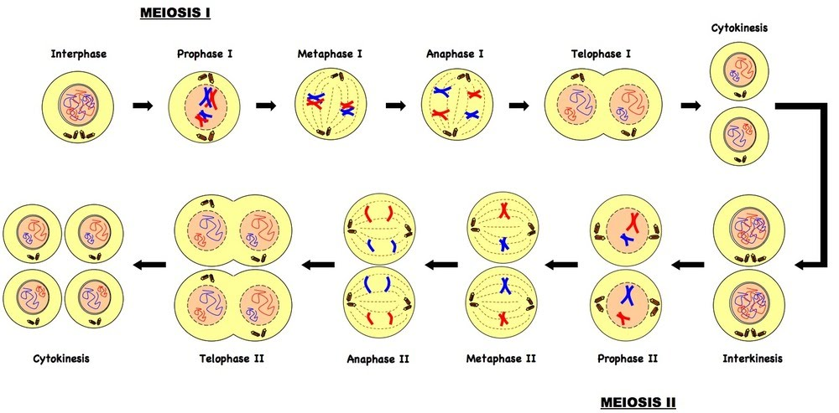

  - DNA replication using the Watson and Crick DNA model, including nucleotide composition, pairing and bonding

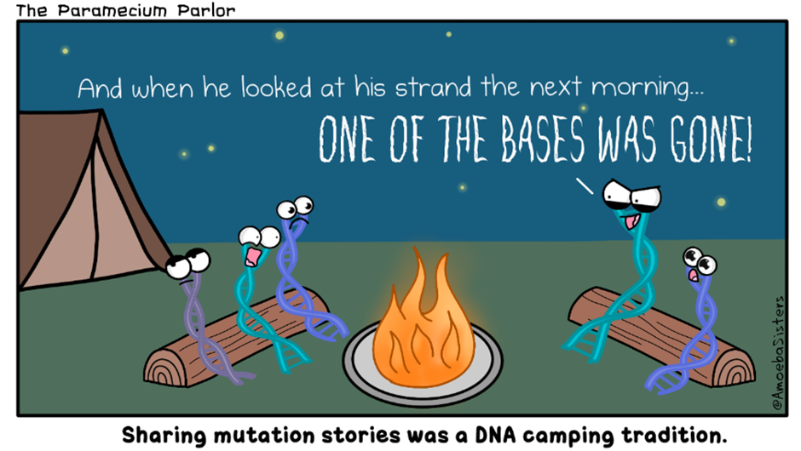

- DNA Structure – the Watson and Crick Model
- Prepare a paper on the discovery of DNA and the Watson Crick Model of the Structure of DNA.

- DNA replication
- DNA replication involves copying a strand of DNA. This process occurs during mitosis and meiosis
- During the ‘resting phase’ when the cell is not dividing, the DNA must undergo replication- the process of forming an identical copy.
- Enzymes play an important part in helping DNA to replicate.
- Replication is essential for copying information to make proteins, which carry out cellular processes.
- DNA is made up of 4 chemical bases: adenine (A); Thymine (T); Guanine (G) and Cytosine (C).
- Cytosine is complementary to Guanine and Adenine is complementary to Thymine.
- Steps in replication:
- DNA is unzipped by an enzyme called Helicane which forms a replication fork.
- Primase starts the process. This forms a ‘primer’ which makes the starting point.
- DNA polymerase begins replication by adding specific DNA bases.
- When replication is complete, DNA Ligase seal up fragments in both strands to form a continuous double strand.
- DNA replication is semi-conservative – 1 old strand and 1 new strand
- DNA replication is important because it creates a second copy of DNA that must go into one of the two daughter cells when a cell divides. Without replication, each cell lacks enough genetic material to provide instructions for creating proteins essential for bodily function.
- Nucleotide Pairing and Bonding
- DNA strands are composed of a sugar-phosphate backbone. The two strands of the DNA double helix run parallel together but in opposite directions.

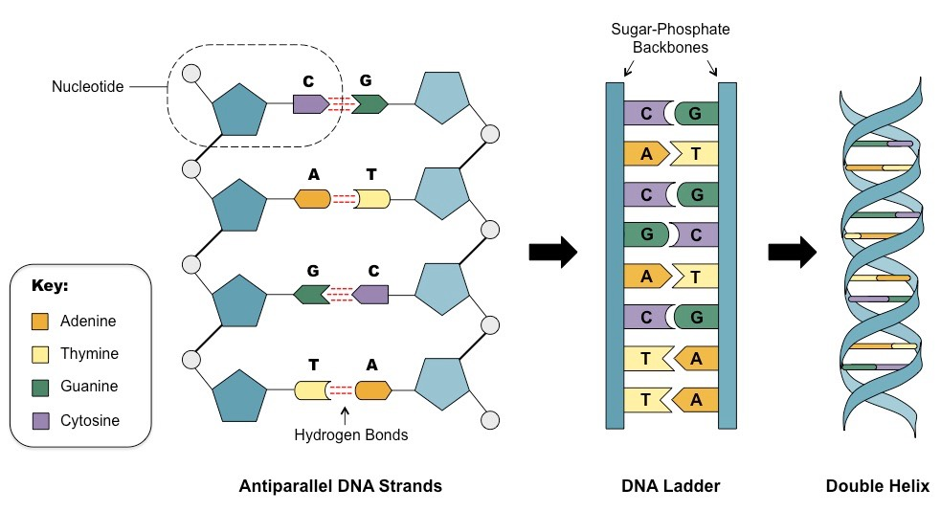

- A nucleotide is a sugar, phosphate and base.
- The 4 bases are Adenine (A), Thymine (T), Guanine (G) and Cytosine (C)
- The nucleotides in a base pair are complementary, which means their shape allows them to bond together with hydrogen bonds.
- Adenine bonds with thymine and guanine bonds with cytosine.
- The A –T pair forms 2 hydrogen bonds.
- The G – C pair forms three hydrogen bonds.
- The hydrogen bonds between complementary bases holds the two strands of DNA together. The nucleotides in a base pair are complementary which means their shape allows them to bond together with hydrogen bonds.
- The A-T pair forms two hydrogen bonds.
- The C-G pair forms three.
- The hydrogen bonding between complementary bases holds the two strands of DNA together.
- Attached to each sugar ring is a nucleotide base, one of the four bases Adenine (A), Guanine (G), Cytosine (C) and Thymine (T).
- The first 2 (A & G) are examples of a purine. The second 2 (C & T) are examples of a pyrimidine.
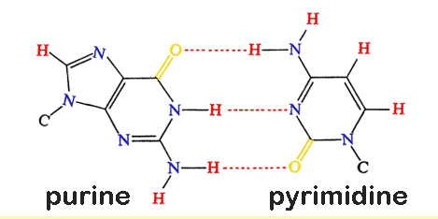

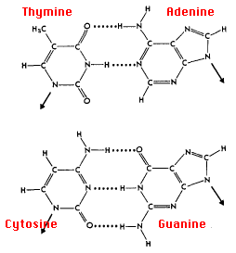

- assess the impact of cell replication processes on the continuity of species

- The importance of accuracy during DNA Replication
- DNA makes up the genetic code of an individual, therefore exact replication is critical for 2 main reasons:
- Heredity – the genetic material transmitted from cell to cell (by mitosis) and from generation to generation (by meiosis) needs to be accurate.
- Gene expression – the genetic instruction given to a cell to create its structure and ensure its correct functioning must be accurate.

Correct gene expression is essential for the production of proteins, differentiation and specialisation of cells and overall for the correct metabolic processes and function of the organism.

- Continuity of the Species
- The continuity of the species refers to the ongoing survival of the species as a result of characteristics being passes from parents to offspring in a continuous lineage.
- Accurate DNA replication brings about genetic variability, whereas mutation results in genetic variation. Both play a role in ensuring the continuity of the species.

- Genetic Continuity
- Genetic continuity is the preserving of genetic information across generations and is dependent on two things:
- Mitosis must produce 2 daughter cells that have the same number and type of genes as the original cells.
- When 2 sexually reproducing organisms breed, the resulting offspring must have the same number of genes as the parent organisms and variations in these genes must not be extremely detrimental or lethal.

- Ensuring the continuity of species – genetic stability
- The mechanisms that have evolved to ensure genetic continuity and the survival and continuity of the species include:
- Consistent replication of chromosomes prior to cell division
- An orderly distribution of chromosomes when cell divide and gametes form
- Fertilisation methods that ensure the species breed successfully
- Methods to ensure embryo survival
- Natural selection
- Mutation – must be beneficial to the species
- Mixing of parental genes during sexual reproduction

- DNA and Polypeptide Synthesis
Inquiry question: Why is polypeptide synthesis important?
- construct appropriate representations to model and compare the forms in which DNA exists in eukaryotes and prokaryotes
- DNA in pro/eukaryotes
- Cells are the basal unit of all living organisms (except viruses, but these are not true, independently living organisms). There are two kinds of cells on the earth: types of cells: prokaryotic cells and eukaryotic cells:
Prokaryotic versus Eukaryotic cells
Prokaryotes | Eukaryotes
Small-sized cell; about 1 µm | A few micrometers, mostly 10 µm, up to about 100 µm
Bacteria and Archaea | Elements of protists, fungi, plants and animals
Occur in general exclusively as single cells, but can also form a kind of clusters (biofilms) | Occur as single cells or as part of multicellular tissue
Single plasma membrane (=cell membrane) | Double plasma membrane
Relatively simple architecture, no organelles, at most compartments | Complex cellular structure; contain specialized organelles, surrounded by a own bilayered lipid membrane
Nucleoid (DNA-protein complex) with large circular DNA molecule, but no distinct nucleus, nor nucleoli, and in general no membrane that separates the DNA from the cytoplasm | DNA linearly arranged in a number of chromosomes packed in a nucleus with a nuclear envelop and nuclear pores
Ribosomes are in general smaller than in eukaryotes | Ribosomesarein general larger than in prokaryotes
After DNA replication, original and replicate DNA attach to a different part of the cell membrane, and binary fission occurs | After DNA replication mitotic division occurs according to the stages prophase, metaphase, anaphase, telophase and cytokinesis
Older (more primitive in evolution) and much more represented | Occurred more recently in evolution and less abundant
populate greatest diversity in environment, can also live in extreme conditions as pH, temperature, salinity, gas, pressure, and show richest biochemistry | More restrained in colonization and biochemical pathways

- DNA in Prokaryotes and Eukaryotes

Summary of the location of the genome in Prokaryotes and Eukaryotes
The genome of most prokaryotes is held within a long single circular DNA that is (super) coiled in loops to form a nucleoid. Nonessential genes are commonly encoded on extrachromosomal plasmids.
Genome packaging in prokaryotes: the circular chromosome of E. coli.
In eukaryotic cells, like in the maize cell shown here, DNA is located in the nucleus, the mitochondria and the chloroplasts (occurring only in plants and some protists).
- The nucleus contains most DNA. It is present in this compartment in the form of linear chromosomes that together constitute the genome. These chromosomes are identical and equal in number in all cells of an individual (except reproduction cells and mutated cells).
- Mitochondria contain a relatively small amount of DNA that is arranged in circular molecules. This DNA carries only a few mitochondrial genes. Most genetical information regarding the mitochondrion itself are present in the nucleus.
- Chloroplasts also contain a limited amount of DNA, in circular or linear arrangement. Like in mitochondria, also this DNA carries only a small part of the genes involved in making proteins required by chloroplasts (chromosomes in the nucleus are also for these organelles the main source of genes).

- model the process of polypeptide synthesis, including:
  - transcription and translation
  - assessing the importance of mRNA and tRNA in transcription and translation

- DNA controls the production of polypeptide chains, which make up proteins.
- There are 20 different amino acids that can be used to form different polypeptide chains.

- Transcription:
- Occurs in the nucleus.
- DNA is used as a template to make RNA.
- The DNA unwinds and unzips. The enzyme RNA polymerase performs this function.
- Transcription occurs in 3 stages:
- Initiation
- Promoter region functions as a recognition site for RNA Polymerase to bind.
- Binding causes the DNA double helix to unwind and open. (Unzip)

- Elongation
- RNA Polymerase slides along the DNA strand.
- Complementary bases pair up and nucleotides are linked.
- Termination
- At termination all sections are released.
- The transcript is then edited through splicing. In molecular biology, splicing is the editing of the transcript. After splicing, introns are removed and exons are joined together (ligated). For nuclear-encoded genes, splicing takes place within the nucleus either co-transcriptionally or immediately after transcription.
- The mRNA strand moves into the cytoplasm through a nuclear pore, to the ribosome.

- Translation:
- A ribosome attaches to the mRNA
- Amino acids are brought to the ribosome by transfer RNA (tRNA).
- Each tRNA has a specific amino acid.
- Bases on the mRNA are in 3 letter codes called ‘codons’.
- In RNA thymine is replaced by uracil as the base complementary to adenine.
- Codons code for specific amino acids.
- Start codon is AUG
- Stop codons are UGA, UAG & UAA
- Transfer RNA; tRNA code for specific amino acids and bind to the mRNA using anti-codons.
- Elongation - The amino acids link to create an amino acid chain.
- Termination occurs when a stop codon is reached.
- Amino acids are joined with polypeptide bonds. The amino acid chain forms a polypeptide, and these fold to create proteins for normal cell function.
- DNA replication allows the process of mitosis and meiosis to occur, which allow a species to survive and continue. Large amounts of coded information can pass from one generation to the next.

- Mutations in the code result in genetic variation, which may be favourable for evolution.
- For Example: TCT, TCC, TCA on the DNA strand in the nucleus codes for the amino acid ‘serine’.

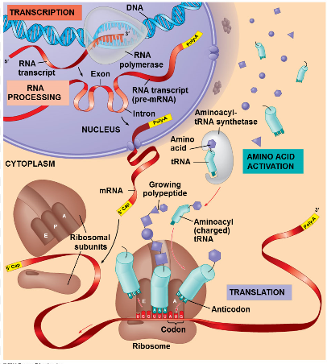

  - analysing the function and importance of polypeptide synthesis
- Protein Function
- Proteins control all aspects of cell functions.
- The cells need protein synthesis to produce a variety of functional, structural and regulatory units (proteins) that allow their proper functioning and development.
- Enzymes are protein molecules that catalyse biochemical reactions. For example amylase breaks down starch into sugars.
- Hormones are proteins that are able to transmit signals from one body location to another. Insulin is an extracellular protein which regulates the metabolism of glucose controlling the levels of blood sugar.
- Contractile proteins like actin and myosin in muscles, are involved in movement.
- Structural proteins are usually filamentous and are used to provide support. Collagen and elastin are important components of the connective tissue, which builds tendons and ligaments.
- Transport proteins supply different cellular processes with the required ions, small molecules, or macromolecules such as another protein. The most common transport proteins are integral membrane proteins which are involved in the transport of substances across the cell membrane.
- Antibodies are proteins involved in the immune response. Their primary function is to bind to antigens.
- In general, information encoded in the DNA is expressed by the functions of proteins.

  - assessing how genes and environment affect phenotypic expression

- Phenotype in this context includes the structure, behaviour and physiology of an organism as well as its appearance.
- Identical twins have identical genotypes, therefore any phenotypic differences must reflect the differences in their environment.
- Embryonic stem cells are capable of dividing and giving rise to any type of cell.
- Some cells will continue to divide and other cells will take the path of specialisation which results from the expression of genes.

- Environmental Effects on Gene Expression and Phenotype
- An example of how the environment can affect gene expression is human height and infant birth weight have a genetic basis, but a lack of nutrients or the presence of toxins (cigarette smoke) can restrict growth.

- Summarise the example of the Siamese cat p130 of text in the summary book.

- investigate the structure and function of proteins in living things
  - Proteins are made up of one or more polypeptide chains
  - Each protein is folded into a particular shape which is crucial to its function.
  - Its shape as well as its chemical properties allow it to function in a particular way.
- For example, haemoglobin is made up of four polypeptide chains.

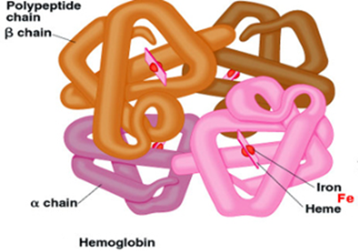

- There are 20 amino acids that can bond together to form polypeptide chains.
- Polypeptide chains can have up to 300 amino acids.
- The amino acids are joined together by peptide bonds, hence the term ‘polypeptide’
- The sequence and arrangement of the amino acids determines the type of protein.

- The structure of proteins can be described at 4 levels:

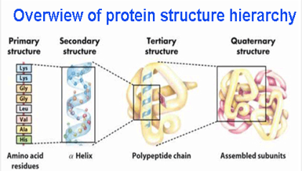

- Primary Structure. The primary structure of proteins is a polymer chain of amino acids in a linear chain of polypeptides.
- Secondary structure is a three-dimensional arrangement of polypeptide chains. This results by the formation of hydrogen bonds between amino acids on different chains.
- Tertiary structure is a more complex protein structure as in globular proteins. Forces of attraction between alpha helices and pleated sheets cause the poly peptide to fold into a more complex three dimensional shape.
- Quaternary protein structure occurs in proteins that are made up of two or more polypeptide chains that link to create a more complex 3D structure. For example the silk of a spider contains pleated sheets joined by less ordered helices.
- Conjugated proteins are linked to a non-protein part called a prosthetic group cofactor. If the cofactor is tightly bound it is termed a prosthetic group and may be an organic or inorganic metal ion.
- Haemoglobin contains inorganic iron as its prosthetic group.
- If the cofactor is loosely bound to an enzyme it is known as a coenzyme, often an organic molecule such as a vitamin.

- Functions of Proteins
- Structural proteins
- Structural proteins provide support and movement
- Often fibrous and stringy as in collagen and elastin (types of protein).
- Found in connective tissues such as skin, cartilage, bone, tendons and ligament
- Contractive proteins allow muscles to contract

- Enzymes
- Enzymes control biochemical reactions.
- Enzymes are proteins involved in all biochemical cellular metabolism
- The shape of its active site determines its binding specificity and therefore, its ability to function.
- Enzymes are important in gene functioning, replication, repair and transcribing DNA to make new proteins.

- Cell signalling and biological recognition
- Proteins such as hormones and neurotransmitters act as chemical messengers between cells.
- They trigger responses in target dell functioning
- Receptor proteins in cell membranes receive signals
- Identify cells as “self”
- Provides recognition between chemical messengers and their target cells.
- Antibodies are defence proteins that can be attached to a cell or freely floating in body fluids.

- Transport and storage proteins
- Ligand-binding proteins carry and store chemicals in the body
- Haemoglobin is an example, as it carries oxygen around the body.
- Also albumin (in egg whites) and casein (in milk) both store proteins.

- Sensory Proteins
- Respond to stimuli
- They can change their shape or biochemical activity in response to stimuli.
- Opsins in the retina undergo a change in molecular arrangement which starts a series of reactions that change light energy into electrical and chemical signals that can be interpreted by the brain.

Genetic Variation
Inquiry question: How can the genetic similarities and differences within and between species be compared?

- conduct practical investigations to predict variations in the genotype of offspring by modelling meiosis, including the crossing over of homologous chromosomes, fertilisation and mutations

- Genetic Variation : Meiosis, Fertilisation and Mutations
- Variation is evident in individuals (for example, differences in fur colour or height). In genetics, the term variability relates to the different forms of a gene within a population – that is, the total of all alleles present in the gene pool of a population (for example, coat colour in a population of Australian kelpie dogs include black, red, blue or fawn coat colour.
- There are several ways in which variation arises during sexual reproduction, including during the processes of meiosis and fertilisation. Mutation is another way of introducing genetic variation.
- Every species has a characteristic number of chromosomes in every body cell (for example, 46 chromosomes in humans).
- A diploid parent cell contains two sets of chromosomes – one paternal and one maternal set. Each pair of chromosomes in the cell is termed a homologous pair, because the two chromosomes carry alleles for the same genes.

- Similarities Between Meiosis and Mitosis
In both mitosis and meiosis:
- The names of the stages – interphase, prophase, metaphase, anaphase and telophase – are the same.
- Interphase occurs first, prior to nuclear division. During this stage, the DNA replicates, so each chromosome makes an identical copy of itself.
- Chromatin material transforms into chromosomes in the same way during prophase in the first meiotic division.
- The breaking down of the nuclear material and the formation of the spindle are the same.
- Cytokinesis in meiosis takes place in the same manner as in mitosis, depending on whether the cell that is dividing is a plant or an animal cell.

- Meiosis I and Genetic Variation
- Meiosis occurs in two stages: meiosis I (the first meiotic division) and meiosis II (the second meiotic division). The reduction in chromosome number occurs in meiosis I.

- Meiosis I
- Chromosomes line up in pairs (one maternal and on paternal chromosome in each pair) during prophase I.
- Crossing over or synapsis occurs – the arms of a pair of homologous chromosomes, termed a bivalent, wrap around each other and the points at which they meet are called chiasmata (singular chiasma).
Genes that occur on the same chromosome are said to be linked. Crossing over (synapsis) ensures that not all linked genes on a chromosome are inherited together. The exchange of genes during crossing over causes mixing of paternal and maternal genes and introduces genetic variation. No two chromatids are identical.

- Each pair of chromosomes separates (during anaphase I) and one entire chromosome of each pair moves into a daughter cell. (Each chromosome still has two sister chromatids attached to each other.) This separation of maternal and paternal chromosomes not only halves the chromosome number in gametes, but also leads to genetic variation, depending on which chromosome (paternal or maternal) of each pair ends up in which daughter cell. This is termed independent assortment of chromosomes and produces different combinations of genes in different gametes.

- Meiosis II
- The two daughter cells that result from meiosis I each undergo meiosis II, which is similar to mitosis but each cell ends up with its own unique set of daughter chromosomes.
- The centromere divides and the chromatids separate from each other (during anaphase), moving to opposite poles (telophase), where a nuclear membrane forms around each set of chromosomes. Cytokinesis follows, resulting in four daughter cells (a tetrad), each with half the original chromosome number. Genetic variation has also been introduced, because the combination of paternal and maternal chromatin material is each resulting daughter cell is different.
- Many combinations of chromosomes are possible in gametes as a result of meiosis, resulting in a variety of gametes forming. Further variation is introduced during fertilisation, depending on which gametes fuse.
- The process of fertilisation, which involves the random meeting of any two gametes, ensure further mixing of genetic material, producing variations in phenotype that may be acted on through natural selection in the process of evolution.
- Another source of variation in mutation, which may arise at any point in the process but most commonly occurs during replication of DNA prior to the start of cell division (for example, during meiosis).
- Independent assortment – chromosomes line up across the cell centre in homologous pairs, with paternal and maternal assortment being independent.
- Random segregation and halving of the chromosomes in the formation of a human gamete. Predict how many combinations would be possible in your hypothetical cell with three pairs of chromosomes.

- model the formation of new combinations of genotypes produced during meiosis, including but not limited to:
  - interpreting examples of autosomal, sex-linkage, co-dominance, incomplete dominance and multiple alleles
  - constructing and interpreting information and data from pedigrees and Punnett squares
- Genotypes and Inheritance Patterns

- Mendelian inheritance, proposed over 170 years ago by Gregor Mendel, is the basis of all inheritance patterns.
- Once Mendel’s laws were explained in terms of modern genetics, the model known as modern synthesis arose, combining the understanding of Mendelian genetics with Darwinian evolution and giving us our modern-day theory of evolution (sometimes called neo-Darwinism).

- Autosomal Recessive Inheritance
- Mendel’s model of inheritance was based on a specific set of conditions – this pattern of inheritance is known as autosomal recessive inheritance.
- Autosomal recessive inheritance occurs under the following conditions:
- A version of each characteristic or trait in an individual is inherited from both parents and is therefore controlled by a pair of inherited factors (called alleles).
- Alleles pass from one generation to the next according to set ratios.
- The alleles is an individual may be the same (in pure-breeding or homozygous individuals or may differ (in hybrid or heterozygous individuals).
- In hybrid individuals that trait that is expressed (appears) is known as the dominant allele, whereas the one that is hidden or masked is the recessive allele (Mendel’s first law – dominance). For a recessive trait to be expressed, both alleles in an individual need to be recessive.
- During gamete formation, the pair of alleles for a trait segregate (separate) and each gamete receives only one allele for the trait/gene (Mendel’s first law – segregation)
- When the inheritance of more than on trait/gene is studied, the pairs of alleles for each trait separate independently of the other pairs of alleles (Mendel’s second law – independent assortment).

- Modern Genetics Terminology Used to Describe Inheritance Patterns
- Genes on chromosomes determine characteristics that are inherited.
- Alleles are different forms of the same gene and occur in pairs in diploid individuals,
- Alleles are found in identical positions of loci (similar locus) on pairs of homologous chromosomes with cells.
- Diploid individuals have two alleles of each gene, and haploid cells (gametes) have only one allele of each gene.
- The phenotype of an organism, simply put, is its appearance (the expression of an organism’s genes). The genotype of an organism is the combination of genes that is present in each cell.

- Today we know that, at a molecular level, the phenotype is more complex than just an organism’s appearance. It is the sum of the gene products (proteins and RNA) that are made and these give rise to not only the physical appearance, but also the behaviour and functioning of organisms.

- Autosomal Recessive Inheritance and Genetic Crosses
- Mendel studied the inheritance of each trait individually (for example, trait = stem length), investigating the inheritance of one pair of contrasting features at a time (for example, tall or short stem length). He studied the following traits and their alternative forms:
- stem length – tall or short
- colour of seed contents – yellow or green
- colour of seed coat – grey or white
- shape of seeds – round or wrinkled peas
- colour of unripe pod – yellow or green
- flower position – axial or terminal
- pod shape – inflated or constricted.
- The traits Mendel studied were typical examples of the autosomal recessive inheritance pattern we know today. That is, if two alleles of a gene are present in a population, one allele is dominant (seen in the phenotype) and the other allele is masked or recessive.
- Autosomal recessive inheritance also assumes that these alleles are located on one of the non-sex chromosomes (autosomes).
- The different alleles are distinguished by using a capital letter for the dominant allele (for example, T) and a lower case version of the same letter for the recessive allele (t).

- Mendel’s Monohybrid Cross
- Mendel carried out a pure-breeding cross followed by a monohybrid cross. That is, he crossed two parents (P) who were pure-breeding (homozygous) for both characteristics – for example, TT and tt. All offspring (F₁ or first filial generation) appeared phenotypically tall, but when they were cross-bred, their offspring (F₂ or second filial generation) gave the phenotypic ratio of 3 tall : 1 short.
- Mendel used mathematical calculations to show that this type of inheritance pattern required one factor to be passed on from each parent to the F₁ generation, who were hybrids (Tt). When these F1 hybrids were bred, they gave a genotypic ratio in the F₂ generation of 1TT:2Tt:1tt.
- It was from these ratios that Mendel derived his first law of dominance and segregation.

- Mendel’s First Law of Dominance and Segregation
- The characteristics of an organism are determined by factors that occur in pairs. Only one member of a pair of factors can be represented in any gamete, (segregation).

- Mendel’s Second Law of Independent Assortment
- In this law, he established further ratios showing that when individuals with two or more pairs of unrelated, contrasting characteristics are crossed (for example, tall plants with yellow pods X short plants with green pods), the different pairs of factors (tall/short and yellow/green) separate out independently of each other.

- Autosomes and Sex Chromosomes
- Every cell in the human body contains 23 pairs of chromosomes: 22 pairs of autosomes (chromosomes that code for general traits within the body) and 1 pair of sex chromosomes.
- Sometimes within a population there are more than two alleles for a particular gene. For example:
- alleles for flower colour in sweet peas – pink, white, purple, red
- alleles for hair colour in Labrador dogs – black, brown or yellow (golden).
- However an individual can have only two alleles and which alleles they possess depends on which pair of alleles have been passed on to them by their parents.
- Multiple alleles in a population give the group greater genetic variability and result in a greater diversity.

- Deviations From Mendel’s Ratios

- Deviations from Mendelian ratios that have been observed over the years can be attributed to changes in typical Mendelian conditions:
- Some genes are not dominant or recessive:
- They may both be expressed – codominance
- A blending of their characteristics may be expressed – incomplete dominance
- Some genes do not assort independently; they are linked. For example genes on the sex chromosomes show sex-linked inheritance.
- Sex determination
- A zygote that inherits an X chromosome from both mother and father will be female, XX.
- A zygote that inherits an X chromosome from its mother and a Y chromosome from its father will be male, XY.
- Sex Linkage
- Sex linkage occurs when some genes carried on the X and Y chromosomes code for characteristics other than the gender of the individual.
- If the gene occurs on the X chromosomes, females will have 2 alleles for that gene whereas males will only have one.
- Therefore, recessive disorders appear more frequently in males.
- For example, in humans the gene for red-green colour vision occurs on the X chromosome. Therefore, if a female has the dominant gene and the mutant recessive gene the male offspring has a greater chance of being red-green colour blind.
- Females that have the mutant (recessive) condition on one X chromosome are said to be carriers.
- Some sex-linked genes are found only on the Y chromosome, Y linked, hence appear in males only. For example Y linked infertility.

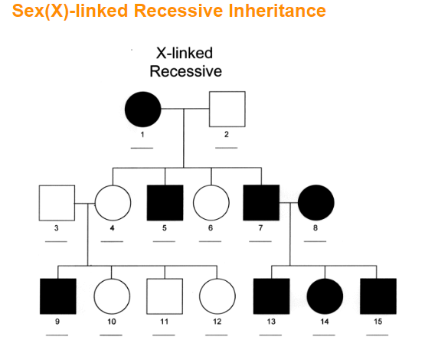
Assign genotypes.

- Symbols used to represent alleles in sex-linked crosses.
- Alleles of the sex-linked gene as well as the type of chromosome on which it is carried (X or Y) must be shown in the genetic cross.
For example for a genetic cross for haemophilia:
X^{H}X^{H} = normal female
X^{H}X^{h} = carrier female (heterozygous)
X^{H}Y = normal male
X^{h}Y = haemophilic male

- Incomplete dominance and codominance
- Incomplete dominance and codominance are examples of inheritance that do not show a Mendelian patter.
- In the genes of some organisms, pairs of alleles so not show dominance of one allele over the other.

- Incomplete Dominance
- Incomplete dominance is a blending of the features of the two alleles expressed, giving a hybrid that is intermediate.
- For example, red snap dragon flowers crossed with white snapdragon flowers give pink flowers.

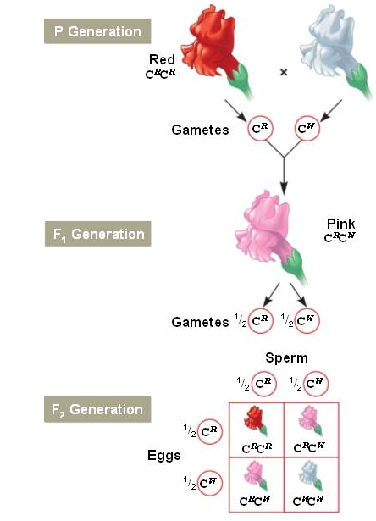

- Codominance in animals
- In codominance, both alleles are expressed creating a new phenotype.
- For example, pure breeding (homozygous) cattle may have a red or white coat colour. Hybrid individuals (heterozygotes), which have one allele for red and one for white coat, have a roan appearance.
- Both red and white hairs are present, not in patches but interspersed.

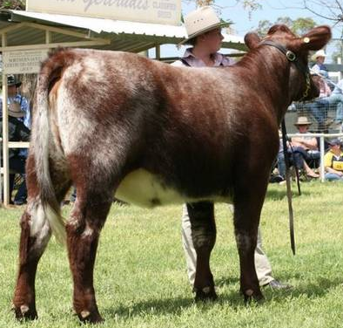

- Multiple Alleles
- Within a population there may be three or more alleles for a single gene trait.
- Such a trait is termed multi-allelic
- For example, in humans, the gene for human blood type has three alleles in the population: A, B and O.
- Blood cells have a ‘self’ marker.
- To represent multi-allelic blood groups using correct genetic notation, the gene is denoted as 1 and the 3 alleles represented by superscripts: 1^{A}, 1^{B}, and1^{i}.
- Alleles A and B are codominant and have markers on red blood cells.
- If both alleles are present (A & B) then the red blood cell will have both markers.
- The i allele has no markers and is recessive to A and B.
- There are 4 possible phenotypes A,B, AB and O.
- There are 6 possible genotypes:

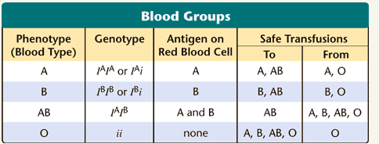

- Solving Genetics Problems
- Representing Autosomal Inheritance Using a Punnett Square
- A Punnett square is a model used to represent inheritance patterns such as autosomal inheritance, as shown in Mendel’s monohybrid cross.
- Models such as this can be used in predicting possible outcomes when certain individuals are cross-bred.
- Punnett squares are often used to calculate the probability that a genetic defect will be inherited by offspring of two parents of known genotype.

- Probability in Genetics
- You have seen how the phenotypic ratio of offspring (3 dominant : 1 recessive) was derived from Mendel’s typical monohybrid cross. This means that, taking the gene for height as an example, three-quarters of the offspring will be tall and one-quarter will be short.
- The probability can also be written as a percentage – there is a 75% probability that offspring will be tall and a 25% probability that they will be short.
- This result will only be obtained with a large sample size, as it is based on probability.

- Pedigree Analysis
- If the traits expressed in a family over several generations are observed, a pedigree chart (family tree) can be constructed to record phenotypes.
- A pedigree chart and analysis is often used to study heredity patterns in families by tracing the inheritance of any particular characteristic, and to make predictions about the expected phenotypes and genotypes of future offspring.
- It is often necessary to study at least three generations to find out the genotype of individuals.
- They show an individual’s biological relatives and then partners as a series of circles and squares, linked by lines. The occurrence of a particular trait within the family is represented by shading.
- A pedigree can therefore be defined as a graphical representation of the inheritance patterns of a particular trait in related individuals over a number of generations.
- Analysis of the pedigree chart is carried out to record:
- how many family members have the trait
- the gender (male of female) of the affected individuals
- how individuals in the pedigree are related.
- This information may be used to:
- determine inheritance patterns
- assign genotypes to individuals where possible
- make predictions about the probability (sometimes the risk of an individual inheriting a trait (for example, a genetic disorder, abnormality or disease).

- Constructing Pedigrees and Analysing Inheritance
- Constructing and analysing a pedigree:
- Gather phenotypic records of that trait in family members over several generations.
- Use symbols to represent the various family members, showing whether they are male (square) or female (circle) and whether or not they possess the trait being studied (shaded = trait being studies is present).
- Assign a number (Roman numeral) to each generation of the family tree and another number (Arabic numeral) to each individual in that generation.
- Use linking lines to represent relationships between people – marriage (horizontal line) and offspring (vertical line).

Table 5.2 summaries features of autosomal inheritance patterns for dominant and recessive genes. Use this table to assist with logical deductions that you need to make when analysing pedigree charts.

TABLE 5.2: Some inheritance patterns evident from pedigree analysis
TYPE OF INHERITANCE | FEATURES | EXAMPLES
Autosomal | Trait follows Mendelian inheritance pattern.
Autosomal Recessive | - The trait is expressed as the result of a recessive gene.  - The affected individual must carry two affected alleles (by homozygous recessive) for this gene to be expressed.  - The gene can be passed on to both males and females in equal proportions.  - The trait appears to skip a generation. | Albinism  Tay-Sachs Disease  Cystic fibrosis  Sickle cell anaemia
Autosomal Dominant | - The trait is expressed as a result of a dominant gene.  - The affected individual must carry at least one affected allele for this gene to be expressed.  - The gene can be passed on to both males and females in equal proportions.  - The trait does not skip a generation. | Huntington’s disease  Achondroplastic dwarfism  Polydactyly

- Inheritance Patterns in a Population
Inquiry question: Can population genetic patterns be predicted with any accuracy?
Students:
- collect, record and present data to represent frequencies of characteristics in a population, in order to identify trends, patterns, relationships and limitations in data, for example:
  - examining frequency data
  - analysing single nucleotide polymorphism (SNP)

- investigate the use of technologies to determine inheritance patterns in a population using, for example:
- DNA sequencing and profiling
- investigate the use of data analysis from a large-scale collaborative project to identify trends, patterns and relationships, for example:
- the use of population genetics data in conservation management
- population genetics studies used to determine the inheritance of a disease or disorder
- population genetics relating to human evolution

- Population Genetics
- Population genetics is the study of how the gene pool population changes over time, leading to a species evolving.
- The gene pool is the sum total of all the genes and their alleles within a population.
- Genetic diversity is the total of all the genetic characteristics in the genetic makeup of a species. It is dependent on genetic variability, the tendency of individual genetic traits in a population to vary.
- Species that have a greater degree of genetic diversity have a greater potential to adapt and survive.
- Measuring genetic variations over time allows predictions to be made as to how populations adapt to their environments and which can evolve and flourish or die out.

- Genetic variations and frequencies of characteristics.
- Genetic variability in a population can be determined by analysing the relative proportion of a given phenotype, genotype or allele within that population.
- Allele frequency is a measure of how common an allele is within a population. Many genes are bi-allele that is they have two variants or two possible alleles within a population, e.g. T and t for the height of pea plants.
- Allele frequency can be calculated by:

Frequency of allele G = Number of copies (G) in the population
Total number of copies of the gene (G + g) in the population

- Single Nucleotide Polymorphism
- The term polymorphism refers to individuals with different phenotypes.
- Polymorphisms usually arise as a result of a mutation (an error in DNA replication).
- A single nucleotide polymorphism (SNP) is where one nucleotide is replaced by another.
- SNP’s arise during DNS replication.
- To be termed a SNP, (rather than simply a mutation), the altered DNA sequence must occur in at least on per cent of the population.
- SNPs (and other variations) may be associated with phenotypic change, such as a change in appearance, enzyme functioning, disease susceptibility or response to drugs.
- However, most SNPs occur in non-coding DNA and do not lead to observable differences.
- Individuals within a population show great variation in the genetic markers they have on their DNA.
- Some genetic markers are associated with specific traits or disorders.
- In studies of genetic markers, called, genome-wide association studies (GWAS), computer technology is used to rapidly scan genetic markers across the genomes of many people to find genetic variations associated with a particular disease.
- Genome-wide association studies are based on the presence of a group of SNP markers, called haplotype, associated with a trait rather than trying to link an individual SNP to a trait.
- Some applications of identifying haplotypes are:
- As indicators of a disease.
- To establish family lineage and determine genetic relatedness of individuals.
- To study evolutionary relatedness.

- Frequency of SNPs and genome-wide association studies.
- On average, the frequency of SNPs is approximately one in every 300 nucleotides in the human genome, giving a total of approximately 10 million SNPs, most of which occur in the non-coding regions (introns).
- In GWAS, SNPs that occur in higher frequencies in people with a particular disease, are compared with people who do not have the disease.
- This identifies SNPs associated with a particular disease. By studying SNPs in groups of 25 – 50 people, polymorphisms occurring in 1 to 3 percent of the population can be detected.
- Haplotype analysis has shown an association between particular SNPs and human diseases such as osteoporosis, asthma, diabetes and Alzheimer’s.
- What is the HAPMAP project?

