Module 4:

OF

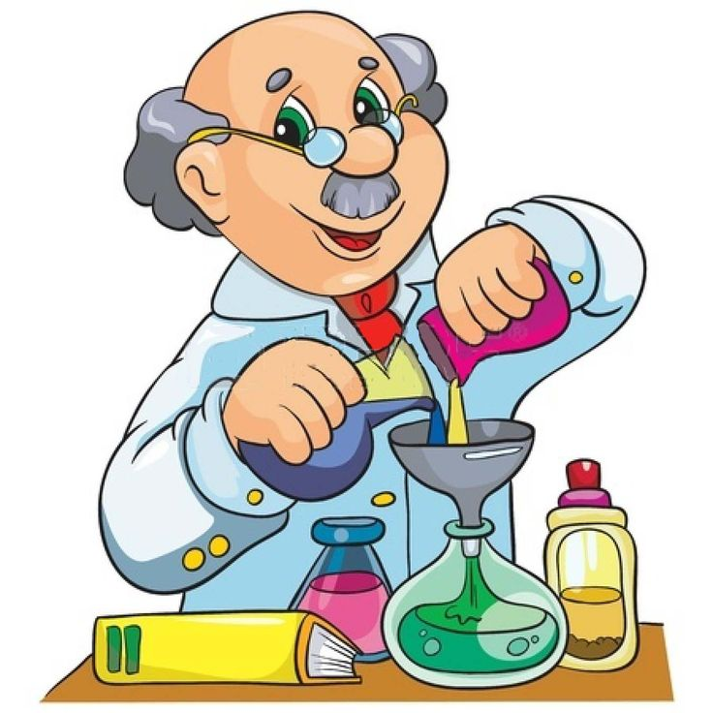

Module 4
Drivers of Chemical Reactions

Content Focus
Students investigate factors that initiate and drive a reaction. They examine the relationship between enthalpy and entropy in calculating the Gibbs free energy. They also examine the roles that enthalpy and entropy play in the spontaneity of reactions. Students conduct investigations to measure the heat energy changes that occur in chemical reactions. They describe reactions using terms such as endothermic and exothermic, and explain reactions in terms of the law of conservation of energy. They use Hess’s Law to calculate enthalpy changes involved in the breaking and making of bonds.

Energy Changes in Chemical Reactions

- conduct practical investigations to measure temperature changes in examples of endothermic and exothermic reactions, including:
  - combustion
  - dissociation of ionic substances in aqueous solution

- A reaction in which energy is released to the surroundings is called an exothermic reaction.
- The enthalpy of the products is lower than the reactants:
- If the reaction is exothermic, ΔTis positive, so the ΔH value is negative.

- A reaction in which energy is absorbed from the surroundings is called an endothermic reaction.
- The enthalpy of the products is higher than the reactants:
- If the reaction is endothermic, ΔTis negative, so the ΔH value is positive.

Investigation 14.1

- investigate enthalpy changes in reactions using calorimetry and $q = mcΔT$ (heat capacity formula) to calculate, analyse and compare experimental results with reliable secondary-sourced data, and to explain any differences

- Water has a higher heat capacity than many other liquids.

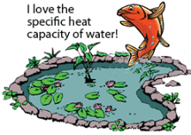

- The specific heat capacity, C, is the number of joules of heat energy required to raise the temperature of one gram of the substance by one Celsius degree, °C or one Kelvin, K.
- Specific heat is measured in J g⁻¹ K⁻¹
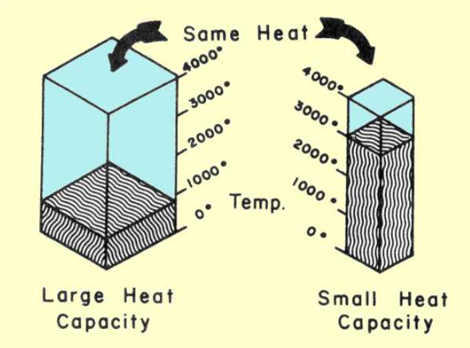

Compare the specific heat capacity of water with a range of other solvents.

Solvent | Specific Heat Capacity  J g⁻¹ K⁻¹
Water | 4.18
Octane | 2.22
Glycerol | 2.38
1,2-ethanediol | 2.39
Ethanol | 2.44
Methanol | 3.53
Benzene | 1.05
Carbon tetrachloride | 0.54

- Explain and use the equation:
ΔH = -mCΔT

- The specific heat capacity may be used to determine the energy absorbed or released when the temperature of a substance increases or decreases. The equation used to calculate the heat energy involved is:

- ΔH = enthalpy of products – enthalpy of reactants
ΔH = -mCΔT
Where:
- ΔH is the heat energy absorbed or released, (joules, J): the change in energy.
- m is the mass of substance being heated or cooled, (g)
- C is the specific heat capacity of the substance being heated or cooled ( J g⁻¹ K⁻¹).
- ΔT is the temperature change of the substance being heated or cooled, (K). (Note that the symbol Δ, (delta), means ‘change in’).
- H is also called the enthalpy of the substance and represents stored chemical energy of the substance.

Other equations:
q = mC∆T joules q = heat of reaction

∆H = q x 1 kJmol⁻¹
1000 x n

Worked Example 14.1 and Try These Yourself p323
Check Your Understanding 14.1 & 14.2 Q4, 5 (a, b & c), 6 & 7

- construct energy profile diagrams to represent and analyse the enthalpy changes and activation energy associated with a chemical reaction

- model and analyse the role of catalysts in reactions

https://www.youtube.com/watch?v=fEXq_RvnYgI

Completed in Module 3

Enthalpy and Hess’s Law

- explain the enthalpy changes in a reaction in terms of breaking and reforming bonds, and relate this to:
  - the law of conservation of energy

- Law of Conservation of Energy
- The Law of Conservation of Energy states that energy can neither be created nor destroyed but transformed from one form to another.
- Explaining Enthalpy Changes
- Chemical reactions involve breaking chemical bonds and forming different ones.
- Energy is needed to break chemical bonds and energy is released when new chemical bonds are formed.
- The bond energy is the energy required to break a particular chemical bond. It is measured in kilojoules per mole of bonds and is always positive.
- When hydrogen burns in oxygen to form water, H—H bonds in hydrogen gas and O—O bonds in oxygen gas break and H—O bonds form to make water.
- When nitrogen gas and oxygen gas combine to form nitric oxide, as occurs in lightning, N—N bonds in nitrogen gas and O—O bonds in oxygen gas break and N—O bonds form to make nitric oxide, NO

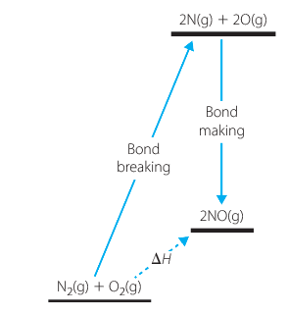

- The Molar Heat of Combustion
- The molar heat of combustion of a substance is the heat liberated whim 1 mole of the substance undergoes complete combustion with oxygen at a constant pressure of 100.0 kPa with the final products being carbon dioxide and liquid water.

- Enthalpy
- Enthalpy is a measure of the total energy possessed by a substance or group of substances.
- Enthalpy can be considered as the chemical energy stored in a substance.
- The change in enthalpy for a chemical reaction, ΔH, is defined as the heat absorbed per mole of specified reactant or product when the reaction occurs at constant pressure.
ΔH = enthalpy of products − enthalpy of reactants

- The Δ in front of a symbol means ‘change in’, and it always means final state (products) minus initial state (reactants) because ΔH is defined as heat absorbed going from reactants to products.
- In endothermic reactions heat is absorbed so the products have more energy than the reactants. For endothermic reactions, ΔH is positive.
- In exothermic reactions heat is released so the products have less energy than the reactants. For endothermic reactions, ΔH is positive.
- ΔH is sometimes referred to as the heat of reaction.
- The figure shows the relationship between enthalpies of products and reactants, and ΔH for endothermic and exothermic reactions.

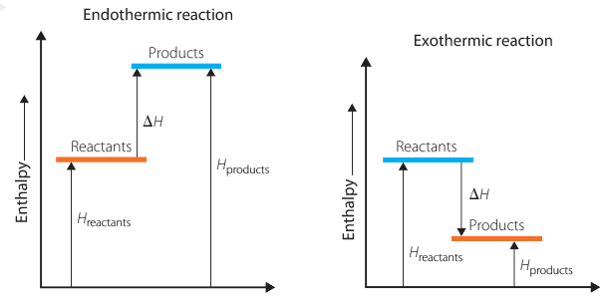

- The definition of ΔH includes the phrase ‘per mole of specified reactant or product’, because it is often possible to write a reaction in more than one way.
- For example, the statement that ΔH for the formation of water from hydrogen and oxygen is −572 kJ is ambiguous because it does not make clear whether the reaction concerned is:
2H_{2(g)} +O_{2(g)} → 2H₂O_{(l)} or H_{2(g)} + ½ O_{2(g)} →H₂O_{(l)}

- Ambiguity is removed by writing: ΔH = −572 kJ per mole of oxygen or ΔH = −286 kJ per mole of water (or per mole of hydrogen)

- Alternatively, the reaction referred to can be specifically written; for example:
H_{2(g)} + ½ O_{2(g)} →H₂O_{(l)} ΔH = −286 kJ mol⁻¹

- Here, ‘per mole’ means ‘per mole of the reaction as written’, in this case ‘per mole of hydrogen’ or ‘per mole of water’.

Worked Example 14.2 and Try these yourself p326

- Chemists also talk about enthalpy changes for the dissolution of substances. The molar enthalpy of solution or heat of solution, ΔH_{soln}, is the heat absorbed when one mole of the substance dissolves in an excess of water.

Investigation 14.2
Worked Example 14.3 p329 and Try these yourself p330
Check Your Understanding Q3,4a, 5 & 8 p331

- investigate Hess’s Law in quantifying the enthalpy change for a stepped reaction using standard enthalpy change data and bond energy data, for example:
  - carbon reacting with oxygen to form carbon dioxide via carbon monoxide

- Hess’s Law
- For a chemical reaction the enthalpy change in going from reactants to products is constant, regardless of what particular set of reaction steps is used to bring it about. This is generally known as Hess's law

- Illustrating Hess’s law
- When carbon burns in a limited supply of oxygen, carbon monoxide is formed.
Reaction 1
2C_{(s)} +O_{2(g)} → 2CO_{(g)}

The enthalpy change for this reaction, ΔH 1, is −222 kJ mol⁻¹, ‘per mole’ meaning ‘per mole of reaction as written’ or ‘per mole of oxygen’ or ‘per two moles of carbon’.

- This carbon monoxide can be reacted with more oxygen to form carbon dioxide.
Reaction 2
2CO_{(g)}+O_{2(g)} → 2CO_{2(g)}

The enthalpy change for this reaction, ΔH 2, is −564 kJ mol^{−1.}

- The sum of these two reactions is:

2C_{(s)} +O_{2(g)} + 2CO_{(g)} +O_{2(g)} → 2CO_{(g)} + 2CO_{2(g)}

- Cancelling out the 2CO_{(g)} on each side and collecting the O_{2(g)} gives:
Reaction 3
2C_{(s)} + 2O_{2(g)} → 2CO_{2(g)}

Reaction 3 is made up of reactions 1 plus 2, so the enthalpy change for it is:

ΔH3 = ΔH1 + ΔH2 = −222 + (−564) = −786 kJ mol⁻¹

- Again, ‘per mole’ in this expression is ‘per mole of the reaction as written’ which means ‘per two moles of carbon dioxide’.
- We can burn carbon in excess oxygen to form carbon dioxide directly.
Reaction 4

C_{(s)} +O_{2(g)} →CO_{2(g)}

- If the enthalpy change is measured for this direct reaction, the value obtained is: ΔH4 = −393 kJ mol⁻¹. This is per mole of carbon dioxide. To compare it with the value from the indirect route, which was per two moles of carbon dioxide, we need to double it

Reaction 5

2C_{(s}) + 2O_{2(g)} → 2CO_{2(g)}

ΔH5 = 2 × -393= −786 kJ mol⁻¹

- Whether we go by the direct route(reaction 5) or via carbon monoxide (reactions 1 +2), the value for ΔH is the same: −786 kJ per two moles of CO₂

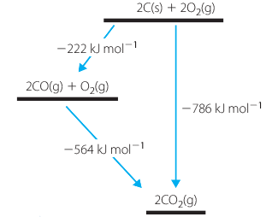

- Hess’s law is widely used to calculate the enthalpy change for a reaction from ΔH values of other reactions. This is commonly done when it is not possible to measure ΔH directly.
- Two important rules are involved in these calculations.
- If a reaction is reversed, the sign of Δ His changed.
- If a reaction is doubled (or halved) then ΔH is doubled (or halved).

Worked example 15.1 and Try This Yourself p347

Check Your Understanding 15.1& 15.2 Q3,5 & 6 p348

- apply Hess’s Law to simple energy cycles and solve problems to quantify enthalpy changes within reactions, including but not limited to:
  - heat of combustion
  - enthalpy changes involved in photosynthesis
  - enthalpy changes involved in respiration

- Enthalpies of formation from heats of combustion. For many compounds, particularly compounds of carbon, the thermochemical quantity that is most easily measured is the heat of combustion. Provided the heats of formation of carbon dioxide and water are known, the standard enthalpy of formation of such compounds is easily calculated.

Worked example 15.3 and Try This Yourself. P355

- Photosynthesis and Respiration
- Photosynthesis is the process in which plants use solar energy to convert carbon dioxide from the air and water from the ground into the carbohydrate, glucose.
- It is a process essential to all forms of life on Earth.
- A simple equation for photosynthesis is:
6CO_{2(g)} + 6H₂O_{(l)}→C₆H₁₂O_{6(aq)}+ 6O_{2(g)}
- Respiration is the process in which living matter generates the energy required for its normal functioning by converting glucose and related carbohydrates to carbon dioxide and water and energy.
- The overall process is effectively the reverse of photosynthesis. For the respiration of glucose the equation is:
C₆H₁₂O_{6(aq)}+ 6O_{2(g)} → 6CO_{2(g)} + 6H₂O_{(l)}

- Respiration is an exothermic process. It releases exactly the same amount of energy (per mole of glucose) as was absorbed in photosynthesis. As with photosynthesis, respiration is a multistep process involving many enzymes.

- Because photosynthesis is a complex process that occurs relatively slowly, it is not possible to measure directly the enthalpy change for the reaction.
- The process of respiration is similarly very complex and so again it is difficult to measure its enthalpy change directly.
- However when we look at the equation for respiration, we note that it is the same reaction as for the combustion of glucose. Chemists can measure heats of combustion fairly simply and accurately.
- The standard heat of combustion of solid glucose is 2803 kJ mol⁻¹and the heat of solution of glucose is +11 kJ mol⁻1, meaning:
Reaction 1
C₆H₁₂O_{6(s)} + 6O_{2(g)} → 6CO_{2(g)} + 6H₂O_{(l)} ΔH 1 = −2803 kJ mol⁻¹
(Enthalpy change is the negative of heat of combustion.)

Reaction 2
C₆H₁₂O_{6(aq)}→C₆H₁₂O_{6(s)} ΔH 2 = −11 kJ mol⁻¹
(Reaction 2 is the reverse of dissolution so its ΔH is reversed also)

Adding equations 1 and 2 and cancelling solid glucose gives:
Reaction 3
C₆H₁₂O_{6(aq)}+ 6O_{2(g)} → 6CO_{2(g)} + 6H₂O_{(l)}
ΔH 3 = ΔH 1 + ΔH 2 = −2803 +(−11) = −2814 kJ mol⁻¹

Hence the enthalpy change for the respiration reaction is −2814 kJ mol⁻¹, and so the enthalpy change for the photosynthesis reaction is +2814 kJ mol⁻¹.

http://employees.oneonta.edu/viningwj/sims/hess_law_s.html
http://science.widener.edu/svb/tutorial/hesslawcsn7.html

Entropy and Gibbs Free Energy

- analyse the differences between entropy and enthalpy

https://www.youtube.com/watch?v=8N1BxHgsoOw

- In exothermic reactions the chemicals move from a state of higher chemical energy to one of lower chemical energy (and energy is released, generally in the form of heat, as this process occurs).
- The physical quantity entropy, S, measures the amount of randomness or chaos or lack of ordered structure in a substance.
- A move from an ordered state to a less ordered one corresponds to an increase in entropy, meaning that for the change ΔS is positive. In the five processes just discussed (students refer to page 366 &367) there was a change from a fairly ordered state to a much less ordered one so ΔS is positive for each of these processes.
- The drive towards greater entropy (greater chaos) is greater than the drive towards lower energy and so the reactions occur in the directions written.
- use modelling to illustrate entropy changes in reactions

Investigation 16.1
Investigation 16.2

- predict entropy changes from balanced chemical reactions to classify as increasing or decreasing entropy

- The standard molar entropy, S, of a substance is the entropy of one mole of the substance in its standard state at the specified temperature (often, but not necessarily, 298 K). Standard molar entropy (often just called entropy) has the units joules per kelvin per mole, J K^{–1}mol^{–1}. Entropy values for some substances are given in Table 16.2 in the textbook.
- The standard entropy change for a chemical reaction, ΔS, is given by:
ΔS =standard entropies of products − standard entropies of reactants
or, written more briefly:
ΔS = ΣΔS (products) − ΣΔS (reactants)
Worked Example 16.2 and Try this yourself p373

- explain reaction spontaneity using terminology, including:
  - Gibbs free energy
  - enthalpy
  - entropy

- Calculating ΔH and ΔS means that we are able to calculate the two drives for a reaction.
- The quantity that does this is the standard Gibbs free energy change, ΔG: it is a measure of the net result of the energy and entropy drives for a reaction. It is calculated from:
ΔG = ΔH − TΔS

where T is the absolute or Kelvin temperature.
- The Tin this equation is needed to make both terms on the right-hand side of the equation have energy units, kilojoules or joules per mole.
- The ‘standard’ in this definition means that all species must be present in their standard states, meaning gases at a pressure of 100.0 kPa and solutes at a concentration of 1.00 molL⁻¹.
- If both the energy and entropy drives for a reaction are in the forward direction – that is if ΔH is negative and ΔS is positive – then the reaction goes in the direction written and ΔG will be negative.
- If both drives are in the reverse direction – that is if ΔH is positive and ΔS is negative – then the reaction will not go and ΔG will be positive.

- Hence, if at a particular temperature ΔG is negative, then under standard conditions the reaction proceeds in the forward direction at that temperature; if ΔG is positive, the reaction goes in the reverse direction.

- solve problems using standard references and ${ΔG}^{o} = {ΔH }^{o}- T{ΔS}^{o}$ (Gibbs free energy formula) to classify reactions as spontaneous or nonspontaneous and predict the effect of temperature changes on spontaneity

Worked example 16.3 p376 &
Try This Yourself p377

