Life on Earth
Part 4

The study of present-day organisms increases our understanding of past organisms and environments
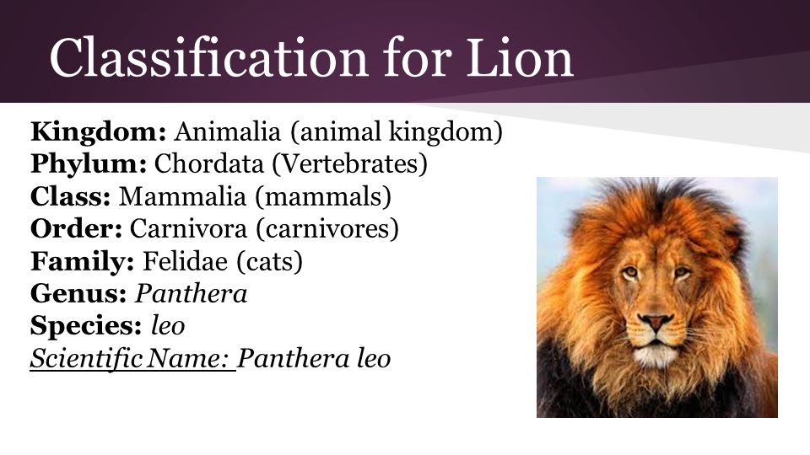
- explain the need for scientists to classify organisms
Classification systems help biologists to understand the relationships between organisms, and to talk to other biologists about organisms without having to describe the organisms in detail.
The science of classifying organisms is known as taxonomy.

Taxonomy, the science of classifying organisms, is needed because:
    - It enables organisms to be DESCRIBED quickly and accurately
    - It makes COMMUNICATION simpler and more precise
    - It lets newly IDENTIFIED organisms belong to particular groups
    - It enables TRENDS in groups to be observed
    - It helps to identify relationships and establish EVOLUTIONARY pathways

- describe the selection criteria used in different classification systems and discuss the advantages and disadvantages of each system
The 2 KINGDOM system, consists of PLANTS and ANIMALS:
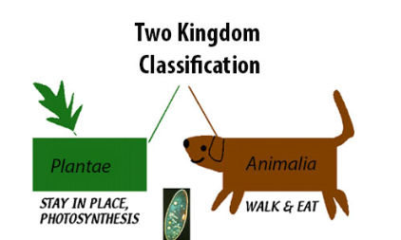
    - Selection criteria:
      - PLANTS: autotrophic, no locomotion, no cell wall
      - ANIMALS: heterotrophic, locomotion, no cell wall
    - Advantages:
- The oldest system that works well with familiar organisms
    - Disadvantages:
      - Some unicellular organisms possess plant and animal traits
      - Does not recognise differences in eucaryotic and procaryotic cells
      - Fungi is difficult to classify
The 3 KINGDOM system, consists of MONERA, PLANTS and ANIMALS:
    - Selection criteria:
      - MONERA: procaryotic
      - PLANTS: eucaryotic, photosynthetic, no locomotion, cell wall
      - ANIMALS: eucaryotic, heterotrophic, locomotion and no cell wall
    - Advantages:
      - Separating the eucaryotes is useful as their structure is different
    - Disadvantages:
      - Some unicellular eucaryotic organisms possess animal and plant traits

  - The 5 KINGDOM system, consists of MONERA, PROTISTA, FUNGI, PLANTS and ANIMALS:
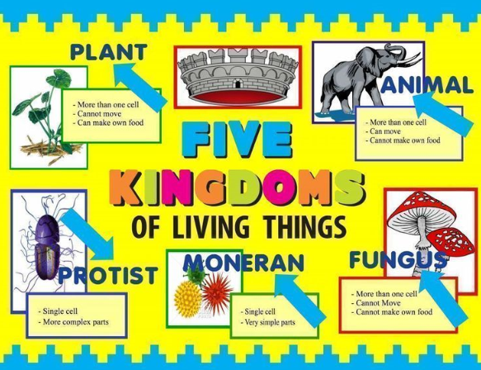
    - Selection criteria:
      - MONERA: Procaryotic
      - PROTISTA: Eucaryotic, unicellular
      - FUNGI: Eucaryotic, multicellular, heterotrophic, no locomotion, cell wall
      - PLANTS: Eucaryotic, multicellular, autotrophic, no locomotion, cell wall
      - ANIMALS: Eucaryotic, multicellular, heterotrophic, locomotion
    - Advantages:
      - Distinguishing fungi from plants is useful, as fungi have no chlorophyll and so are functionally different
    - Disadvantages;
      - Protista contains widely differing organisms and as such is a fairly meaningless group

- explain how levels of organisation in a hierarchical system assist classification
  - In the hierarchical system, the organisms are divided into the following groups: Kingdom, Phylum, Class, Order, Family, Genus, and Species.
  - Organisms are classified into the different levels according to the features they have.
  - Different levels of similarity of difference can be reflected as you go up or down the hierarchy. The lower down you go (from kingdom to species) the more features the organisms have in common.
  - Levels of organisation are very useful for storing and retrieving information, as much information is stored about an organism at each level. For example, all organisms in the Class: mammals have milk glands.

- discuss, using examples, the impact of changes in technology on the development and revision of biological classification systems
  - When organisms were classified just according to their external structure (Linnaeus’ system) there were only 2 kingdoms: plants and animals
  - The invention of the light and electron microscopes, and the discovery of cells and the discovery of micro-organisms increased the number of kingdoms to 5
  - Advances in molecular biology and biochemistry revealed the two major groups within the procaryotic monera: the Archaeobacteria and the Eubacteria.
  - Hence the number of kingdoms has increased to 6
  - The advances in molecular techniques, like DNA and amino acid sequencing have revealed new relationships between organisms
  - All these advances in technology have allowed taxonomists to continually change and refine the current classification systems.

- describe the main features of the binomial system in naming organisms and relate these to the concepts of genus and species
  - Many organisms have many common names, that vary from place to place
  - To overcome this, a binomial system of naming is used to give every organism just one name, consisting of two parts.
  - This name is called the “scientific name” and this system was developed by Linnaeus in the 18th Century
  - In this system, an organism is given a name consisting of 2 parts.
  - The first word has a capital latter and represents the GENUS of the organism
  - The second word represents the SPECIES of the organism and has no capitals
  - Both words are either written in italics or underlined.

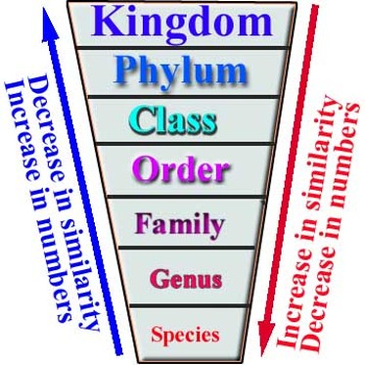

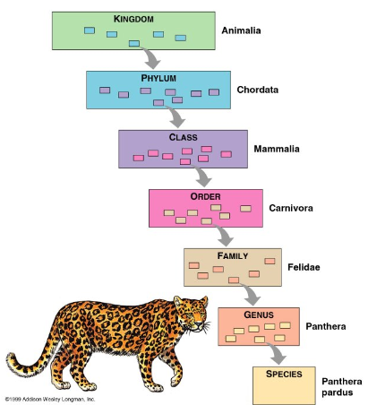

- identify and discuss the difficulties experienced in classifying extinct organisms
  - We only know of many extinct animals from their fossils
  - Fossils can be difficult to classify because they are often incomplete or may not show enough detail of the organism
  - If the organism has been extinct for a very long time, there may be no other organisms to classify it with
  - Fossils can be named even if they only have a part of the fossil
  - If the same organism is given 2 or more scientific names due to incomplete fossils, the first name given is taken as the correct one.

- explain how classification of organisms can assist in developing an understanding of present and past life on Earth
  - Ordering: Grouping organisms together brings a sense of order to a vast range of organisms. Classification also simplifies the description of things
  - Communicating: All scientists throughout the world use the same names no matter what language they speak; this means there is no confusion
  - Relationships: Show relationships with other organisms present today. Some show evolutionary pathways (phylogenetic)
  - Conservation: Through classification and observing organisms in different environments, we can learn about endangered species and try to save them from extinction in the future.

- perform a first-hand investigation and gather information to construct and use simple dichotomous keys and show how they can be used to identify a range of plants and animals using live and preserved specimens, photographs or diagrams of plants and animal

