Life on Earth
Part 3
Further developments in our knowledge of present-day organisms and the discovery of new organisms allows for better understanding of the origins of life and the processes involved in the evolution of living things
- describe technological advances that have increased knowledge of procaryotic organisms
  - These methods are useful for classification, but do not reflect on evolution
  - Two new technologies have enabled a new classification of procaryotes to emerge:
    - Electron microscopes: Shows the differences in the ultrastructure (fine details of cells)
    - Biochemical techniques: Studies of the metabolic pathways in procaryotes have revealed new similarities and differences. Sequencing the amino acids in the proteins and the nucleotides in the DNA and RNA is now possible. These studies are based on the concept that the smaller the difference in the sequence of two organisms, the closer related they are.

- describe the main features of the environment of an organism from one of the following groups and identify its role in that environment:
- Archaea
- Bacteria
Archaea
The Archaea (singular archaeon) constitute a domain and kingdom of single-celled microorganisms.
Archaea can be spherical, rod, spiral, lobed, rectangular or irregular in shape. An unusual flat, square-shaped species that lives in salty pools has also been discovered. Some exist as single cells, others form filaments or clusters. Until the 1970s this group of microbes was classified as bacteria.

Members of the archaea include: Pyrolobus fumarii, which holds the upper temperature limit for life at 113 °C (235 °F) and was found living in hydrothermal vents; species of Picrophilus, which were isolated from acidic soils in Japan and are the most acid-tolerant organisms known—capable of growth at around pH 0; and the methanogens, which produce methane gas as a metabolic by-product and are found in anaerobic environments, such as in marshes, hot springs, and the guts of animals, including humans.

Procaryotic Cell | Environment Where Found | Role in the Ecosystem
Archaeobacteria | Hostile environments such as salty brines (halophiles), boiling springs, ocean thermal vents. | Carry out inorganic reactions for chemical energy hydrogen + sulfur = hydrogen sulphide + energy  carbon dioxide + hydrogen = methane + water + energy

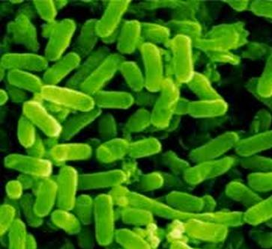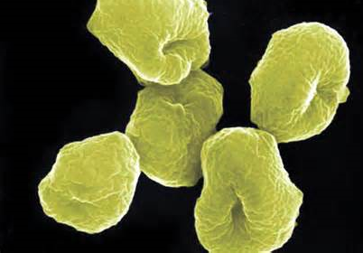

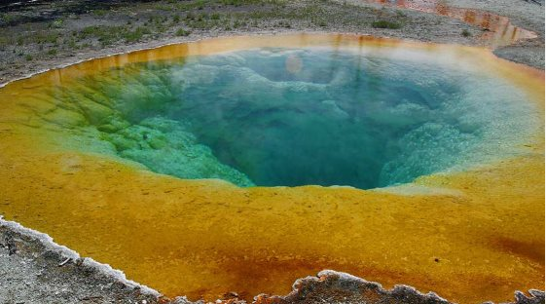

- use the available evidence to outline similarities in the environments past and present for a group of organisms within one of the following:
- Archaea
- Bacteria

Past:  + Cyanobacteria are among the most abundant fossils in PRECAMBRIAN ROCKS (3.5 billion years old). Some scientists think they were the only organisms present at this time. In Precambrian times:  - There was more UV radiation than today  - There was no free oxygen until the first cyanobacteria developed primitive photosynthesis  - The environment would be warm and damp like a mineral water spring  + Stromatolites (made of cyanobacteria) were more common than today and also wider spread.  + Cyanobacteria; some were free-living  + In the Pilbara region, WA, layered rocks 3.5 billion years old have been found. This was at North Pole Dome  + Stromatolites were found in the layered rocks  + These were very similar to the hot-spring stromatolites found.  + Geologists find bacteria in the superheated vents of mineral waters up to 150ºC | Present:  + Cyanobacteria are still common today:  - Damp areas, ponds, streams  - Warm conditions  - Thrive in areas with dissolved calcium bicarbonate  - No longer the only life form  + Today, most are aquatic forms, some are free-living in the soil  - Some are marine stromatolites  - Some live in a mutualistic relationship with fungi (lichens)  + Today stromatolites are found at Shark Bay, WA; Sea water there is really salty  + They occur in those environments close to limestone and low in nutrients  + Stromatolites have also been found in:  - Antarctica  - Hot Springs  - High alkaline lakes  - Lake Clifton WA  + Stromatolites are now in danger of extinction due to rising nutrient levels due to fertilisation. Rise in competition  + This possibly happened in Precambrian times

- analyse information from secondary sources to discuss the diverse environments that living things occupy today and use available evidence to describe possible alternative environments in which life may have originated

Archaea
There are three groups of archaea: methanogens, halophiles and thermophiles. They are all found in unusual or extreme environments.

Halophiles
Environment
Halophiles are found in environments where the salt concentration is very high, such as the.

Dead Sea in the Middle East, the Great Salt Lake in the USA, and evaporating ponds of saline water They are all aerobic.
Halophiles are aerobic organisms, but they also have another system of producing energy. Their red colour is caused by a unique pigment called bacteriorhodopsin, which enables them to photosynthesise and produce energy without using oxygen.

Role in ecosystem
In their ecosystem, halophiles are part of the food chain and are con- sumed by filter feeders. Very little is known about their role in ecosystems, and further research is needed.

Thermophiles
Environment
Thermophiles require high temperatures for growth (80–105˚C). They are found in areas of volcanic activity such as hot springs, geysers, and hydrothermal vents and cracks in the ocean floor. The thermophiles that live in the hydrothermal vents in the depths of the ocean are sometimes called deep-sea bacteria. Thermophiles use sulfur as an energy source.

Role in ecosystem
The deep-sea sulfur-oxidising bacteria in hydrothermal vents are the primary producers (chemoautotrophs) in the deep sea food web and support an amazing community. While the bacteria may form large mats on the sea floor and some organisms feed on them directly, other vent organisms have developed a symbiotic relationship with the bacteria. The organism provides the shelter and the bacteria provide the nutrients.

- Now using the notes above describe possible alternative environments in which life may have originated

