Life on Earth
Part 1

Analysis of the oldest sedimentary rocks provides evidence for the origin of life.

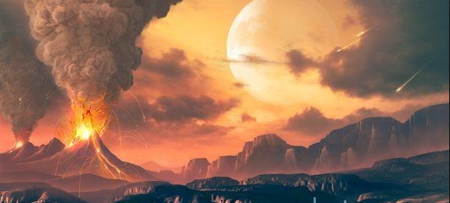

- identify the relationship between the conditions on early Earth and the origin of organic molecules
Conditions of early Earth:
    - Massive oceans existed
    - Only small landmasses above the surface of the water
    - No ozone layer
    - Large amounts of radiation reached the Earth
    - No free oxygen in the air
    - Large amounts of volcanic activity; heat, ash, dust and gases into atmosphere
    - Violent electric storms common
    - Atmosphere contained some water vapour (H2O), hydrogen (H2), hydrogen cyanide (HCN), a lot of carbon dioxide (CO2), nitrogen (N2), possibly ammonia (NH3) and methane (CH4).
  - The chemicals of life are contained within the following basic organic compounds: water, carbohydrates, lipids, proteins, and nucleic acids.
  - These compounds are made up of hydrogen (H), oxygen (O), carbon (C), nitrogen (N) and some other common elements.
  - The elements needed to create the basic organic compounds were already present in the atmosphere; i.e., H, O, C and N were already there.
  - The lack of an ozone layer, the frequent violent electric storms, and the volcanic activity of early Earth could have provided the energy for molecules to be formed.

- discuss the implications of the existence of organic molecules in the cosmos for the origin of life on Earth
For life to have originated, the following events need to have happened:
    - The required chemicals need to have been formed.
    - These chemicals need to have come together in a self-replicating body.
    - This body would need to have a form of protection for its contents.
    - It had to be able to use an energy source to replicate itself.
  - The first step needed for life to be formed would be that the organic molecules needed for life would have to be present
  - These organic molecules could have been formed here on Earth, or come from Earth from outer space (the cosmos).

  - describe two scientific theories relating to the evolution of the chemicals of life and discuss their significance in understanding the origin of life
Theory 1: The chemicals for life came from outer space:
    - Before an atmosphere was formed, nothing stopped meteorites hitting the Earth
    - Scientists believe Earth was heavily bombarded with meteorites during formation
    - Certain types of meteorites, called carbonaceous chondrites, have been found, which contain organic molecules, like amino acids
    - This provided evidence of organic molecules somewhere else in the universe
    - This means that the chemicals for life could have come from outer space
Theory 2: The chemicals for life were formed on Earth:
    - Haldane and Oparin suggested that early Earth contained all the basic chemical components necessary for life
    - They hypothesised that complex organic molecules, like nucleic acids and carbohydrates, could have been created using inorganic molecules through slow reactions using energy from lightning or UV rays.
    - These complex organic molecules could have collected together on the surface of the oceans, forming an organic “soup”, which later could have formed cells
    - The theory was untested until the 1950s, when Urey and Miller tested it in the lab

  - discuss the significance of the Urey and Miller experiments in the debate on the composition of the primitive atmosphere
Urey and Miller performed the following experiment to prove Haldane and Oparin’s theory:
    - A closed system was set up and powerful electrical sparks were passed through a chamber containing ammonia, hydrogen, and methane.
    - These chemicals were used because the scientists wanted to recreate the atmosphere of early Earth.
    - Steam was recycled and passed through the chemicals
    - After a week, the steam collected was red and turbid. When this water was tested, it was found to contain some amino acids.
  - This experiment proved that, if early Earth did contain those chemicals, life could have formed from inorganic molecules.

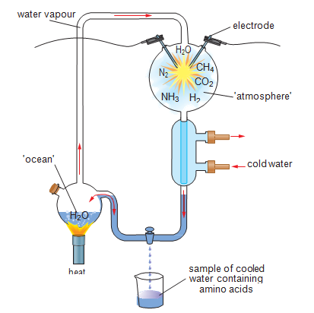

  - identify changes in technology that have assisted in the development of an increased understanding of the origin of life and evolution of living things
  - The Urey/Miller experiment has been improved using modern technology
  - UV radiation and carbon dioxide is used instead of electricity and ammonia and methane, to make the conditions in the closed chamber more like that of early Earth.
  - Advances in technology that has increased our knowledge of the origin of life and evolution are the changes in chemical analysis, biochemistry particularly of DNA and molecular biology.
  - Other technological advances:

Technology | Uses
Microscope | Enabled the discovery or micro-organisms
Radiometric Dating | Can assign absolute dates to rocks/fossils Has established age of the Earth  as 4.5 billion years old
Electron Microscopy | Remains of microbes and mineral nature of rocks can be studied in detail
Gas and Liquid Chromatography Radioactive Tracing  Amino Acid and Nucleotide Sequencing Spectrophotometry | Enabled the comparisons between ancient organic material and biological material  today

- gather information from secondary sources to describe the experiments of Urey and Miller and use the available evidence to analyse the:
- reason for their experiments
- result of their experiments
- importance of their experiments in illustrating the nature and practice of science
- contribution to hypotheses about the origin of life

Reason for the experiment:
- To test the hypothesis of Haldane and Oparin
- i.e. organic molecules could have been created on the surface of early Earth, from inorganic molecules using energy from UV rays and lightning
Result for their experiment:
- After a week of electrical discharge and recycling steam through their apparatus, they analysed the condensed liquid
- It was found to contain amino acids, the building blocks of proteins
Importance of their experiment in illustrating the nature and practice of science:
- It showed that hypotheses and theories are welcomed in science, but are only accepted when backed up with scientific proof, that is, experiments.
Contribution to hypotheses about the origin of life:
- The results supported Haldane and Oparin’s theory that early Earth contained the basic chemical components for life
- It proved that complex organic molecules can be produced from basic chemical components or inorganic molecules

