module 6

Genetic change
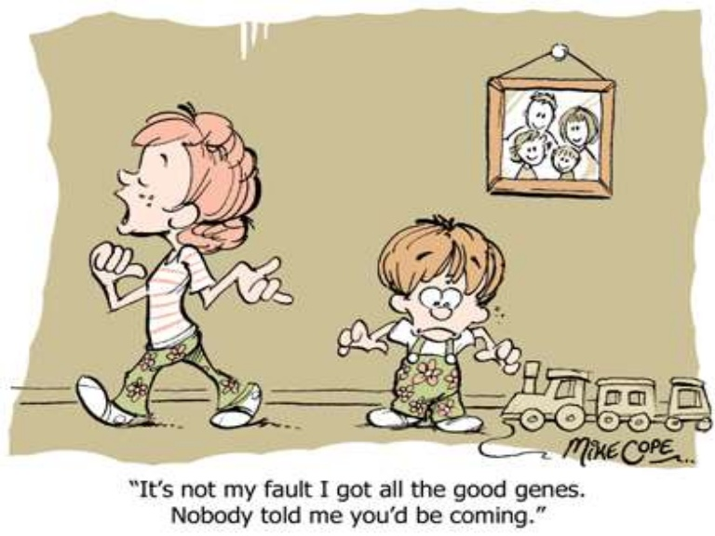

Module 6: Genetic Change

Outcomes
A student:
- solves scientific problems using primary and secondary data, critical thinking skills and scientific processes BIO11/12-6
- communicates scientific understanding using suitable language and terminology for a specific audience or purpose BIO11/12-7
- explains natural genetic change and the use of genetic technologies to induce genetic change BIO12-13

Content Focus
Students learn about natural and human-induced causes and effects of genetic change, including mutations, environmental pressure and uses of biotechnology. Students investigate how the processes of inheritance and evolution are applied.

The work of scientists in various fields of work, including agriculture, industry and medicine, can be explored within the context of biotechnology. The impact of biotechnology on biological diversity is also explored in this module.

Working Scientifically
In this module, students focus on analysing trends and patterns and solving problems using evidence from data and information. Students also focus on communicating ideas about genetic change for a specific purpose. Students should be provided with opportunities to engage with all Working Scientifically skills throughout the course.

Mutation
Inquiry question: How does mutation introduce new alleles into a population?

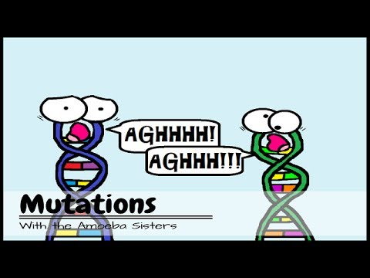

- explain how a range of mutagens operate, including but not limited to:
  - electromagnetic radiation sources
  - chemicals
  - naturally occurring mutagens

- Mutagens
- Mutagenic Agents
- Environmental agents that alter DNA and cause mutations are called mutagens.
- The process of inducing a mutation is called mutagenesis and the resulting mutations are called induced mutations.
- Many mutations are carcinogenic – cancer causing.
- Some mutations occur in genes that regulate the cell cycle.
- This may result in increased cell division with no differentiation which can result in tumours.
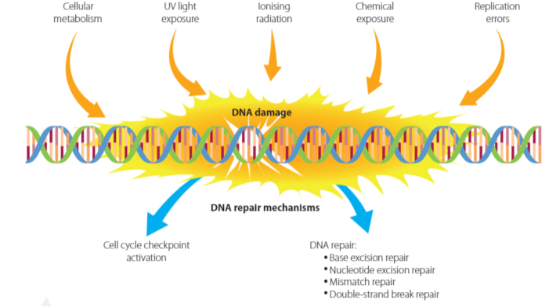

- Chemical Mutagens
- Chemical mutagens cause a change in DNA that alters the function of proteins and, as a result, cellular processes are impaired.
- Cause by high frequency exposure or exposure over long periods of time.
- Examples:
- Ingested chemicals: alcohol, tar in tobacco smoke, some medications, charred and fatty chemicals in food.
- Environmental irritants and poisons: organic solvents, cleaning products and pesticides.
- Many chemical compounds have similar structures to the purines and pyrimidines found in the four bases, (A, T, C & G).
- These chemicals can be incorrectly inserted as a base is replicated. This is termed mispairing. Mispairing can lead to the formation of non-functional proteins.

- Naturally occurring mutagens:
- Naturally occurring mutagens are mutagenic agents that are present at normal levels with natural environments, and may cause mutations.
- These can be divided into 2 groups:
- Non-biological mutagens: metals such as mercury and cadmium, UV radiation and nuclear radiation.

- Biological mutagens: These include viruses, bacteria, fungi and their products.

- End-products of metabolism: The end products of metabolism of fungi, plants and animals can be mutagenic. These can be identified with sudden outbreaks of particular types of cancer.
- Transposons: are sections of DNA that spontaneously fragment and relocate or multiply within the genome. When they insert into chromosomal DNA they disrupt DNA functioning.
- Microbes: can be mutagenic. These include viruses such as hepatitis B and bacteria such as Helicobacter.

- Effects of Biological Mutagens
- Many mutagenic microbes are unable to insert their own by base sequences into DNA and in this way change the functioning of genes and trigger cancers.
- Some bacteria cause inflammation which produces free radicals which can damage DNA. This increases mutations. Examples are the Heliobacter pylori and some mycotoxins.
- Some products made by microbes are mutagenic due to their instability at cellular pH. They decompose to form an intermediate that can bind to cellular DNA and alter it.

- Physical mutagens
- Physical mutagens include heat and ionising radiation.

- Electromagnetic radiation
- The electromagnetic radiation comes from the sun and is a form of energy. It includes radio waves, microwaves and gamma rays.
- Ionising radiation includes the shorter wavelengths of UV radiation as well as X-rays and gamma rays.

- Ultraviolet radiation
- They are of three types of UV radiation.
- These are UVA, UVB and UVC and it is in the middle of UVB and UVC which are high energy and cause chemical damage to DNA which makes this radiation mutagenic and carcinogenic.

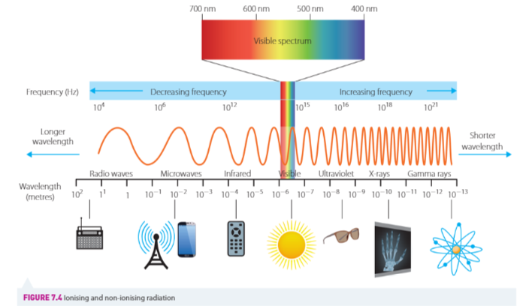

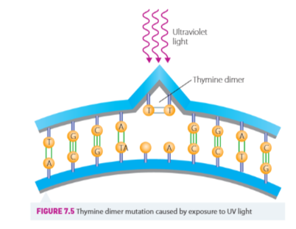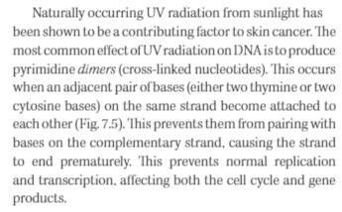

- DNA repair mechanisms operate in cells, whereby enzymes that are involved in replication also play at a role in removing any damaged parts of DNA and the pairing of DNA.
- These mechanisms include:
- Base excision
- Mismatch repair: once DNA has replicated, the enzyme DNA polymerase carries out a ‘spell check’ for accuracy of replication.

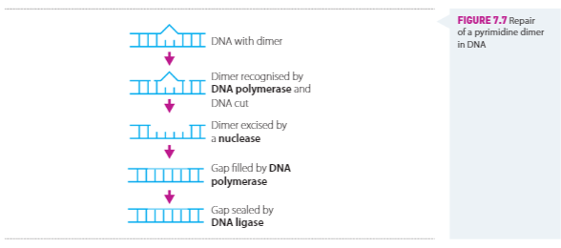

- compare the causes, processes and effects of different types of mutation, including but not limited to:
  - point mutation
  - chromosomal mutation

- Types of mutations.
- Mutation is a collective term for a change in DNA. There are different types of mutations that can be distinguished according to five criteria:
- The origin of the mutation:
- spontaneous mutations arise randomly as a result of a natural process such has DNA replication in cells period
- induced mutations arise as a result of an environmental agent such as a chemical or radiation.
- The amount of genetic material changed:
- Point mutations are changes to a single base pair of DNA and affect only a single gene (gene mutations).
- Chromosomal mutations move whole blocks of genes to different parts of a chromosome or to another chromosome entirely.

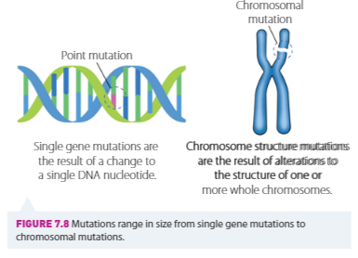

- Frameshift mutations may affect a single gene or a sequence of genes and arise as a result of point mutation or a chromosomal mutation.

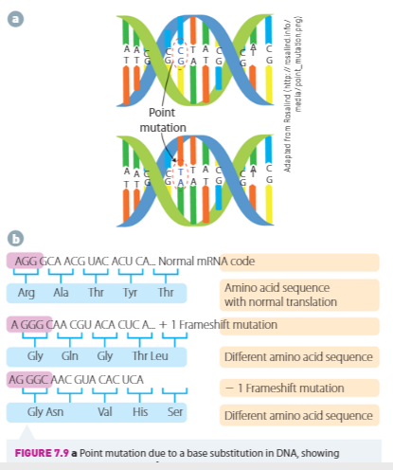
- The effect of the mutation on DNA: a nucleotide base may be substituted, or deleted. This can change the amino acids by changing a codon sequence.
- The effect of mutation on phenotype: they may be no change in the phenotype, or a small or large change in the phenotype, depending on the type of amino acids substituted.
- Heritability of mutations: the mutation has to be in a reproductive (germ line) cells or the mutation will not be passed on.

The effects of mutations:
- Changes in proteins due to point mutations:
- Nonsense mutations – change the amino acid to a stop codon. The resulting protein is usually non-functional.
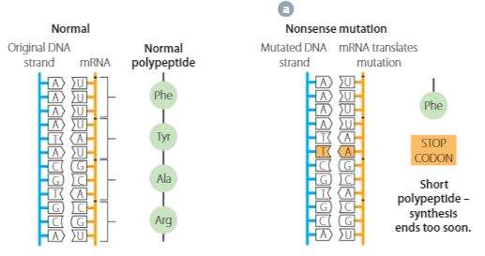

- Missense mutations – a point mutations that result in an amino acid change. Sickle cell anaemia is an example.

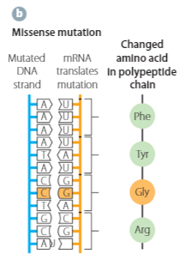

- Silent mutations are changes in the DNA sequence do not cause a change in the amino acid. These changes have no effect on proteins.

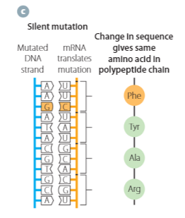

- Neutral mutations are changes in DNA that result in an amino acid of the same type as the original so the structure of a protein is not significantly affected.

- Chromosomal Mutations
Chromosomal mutations are large scale changes where either the overall structure of a chromosome is changed or the entire number of chromosomes in a cell is altered.

- Changes in chromosomal structure.
- There are four main types of chromosomal mutation that alter the structure of chromosomes.
- These are: Deletions; insertions; inversions and translocations.

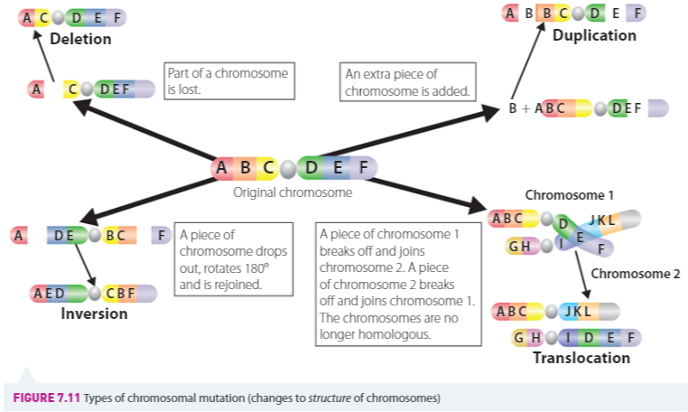

Check your understanding 7.2 p 240

- distinguish between somatic mutations and germ-line mutations and their effect on an organism

- Somatic and germline mutations
- Somatic cells include all cells in the body that are not sex cells. Mutations in these cells cannot be inherited.
- Germ-line cells in the gonads (which produce gametes) produce mutations that can be inherited.
- Somatic mutations
- Often occur due to replication errors of DNA prior to mitosis.
- Spontaneous mutations may occur in the S phase of the cell cycle and, if not repaid during proofreading in the G2 phase, will be passed on to daughter cells.
  - Continued division by mitosis will amplify the error in that tissue.
  - This may be phenotypically observed in the organism as a tumour or disease.
- Somatic mutations are not always visible. They may occur as physiological changes, such mutations are cystic fibrosis, thalassaemia (an inherited blood disorder).

- Germ-line mutations
- These arise in the sexual reproductive cells that give rise to inmates (germ line cells).
- These mutations are passed on to offspring.
- When fertilisation occurs this mutation occurs in every cell of the embryo.
- As the embryo continues to grow and divide, every cell in the organism is affected.

- assess the significance of ‘coding’ and ‘non-coding’ DNA segments in the process of mutation

- Coding and non-coding DNA.
- Mutations in coding genes have a direct effect on proteins.
- Mutations in non-coding DNA may affect gene expression, while others have no effect.

- Mutations in coding the DNA and their significance.
- Mutations in coding genes usually affect the type or sequence of amino acids in a protein product.
- In eukaryotes, mutations may affect gene splicing, which can cause the modification and function of proteins.
- For example, the colour of iron else’s code depends on the presence of proteins, including enzymes that make the pigments.
- Therefore, if a mutation occurs in DNA, in the region that codes for coat colour then need protein may be affected and therefore, the phenotype of the individual is affected.
- In prokaryotes most DNA is coding DNA. Here most genes are for the DNA repair enzymes. Hence any mutation can be catastrophic for the organism, for example in bacteria.
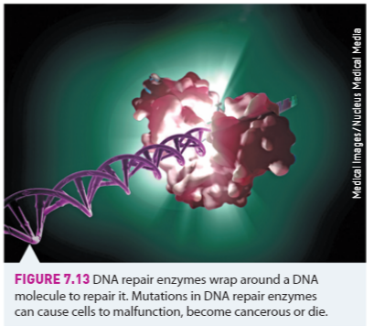

- Mutations in non-coding DNA and their significance.
- In eukaryotes some parts of non-coding DNA of important functions. They may contain regulatory sequences that in “switch on” genes or “switch off” genes.
- For example, small nuclear RNA has an important function in gene expression. Plays a role in determining which introns are spliced out of DNA in the formation of mRNA.
- Mutations in these non-coding regions have been shown to affect gene expression and cell functioning.

Investigation 7.2 Part B

- investigate the causes of genetic variation relating to the processes of fertilisation, meiosis and mutation
- In a population there may be a variety of alleles for each gene. For example, could be alleles of red, brown, black and blonde for the gene for hair colour.
- Hence, there is greater variability for more gene combinations to arise in gametes produced by individuals.
- Therefore, variability may be increased as a result of:
- Recombination of genetic material through meiosis and fertilisation
- The increased number of alleles for a particular journey up

- Meiosis I and genetic variation
- When gametes form, crossing over and random segregation in meiosis result in genetic recombination of paternal and maternal genes within each gamete. At
- When gametes unite in fertilisation, a further mixing of genetic material occurs and this results in offspring with many new combinations of genes.

- Chromosomal errors
- The DNA to be exchanged during synapsis may be converted before it is inserted on to the arm of a corresponding chromatid.
- A chromosome may break and, if this is followed by a duplication of the chromosome, the two chromatids that fuse may now have two centromeres. When they play a part in anaphase, one chromatid will have a duplication and one will have a deletion.
  - These chromosomal changes may be brought about by exposure to mutagens during meiosis.

- Changes in the chromosomal numbers (non-disjunction).
- When one or more pairs of homologous chromosomes or sister chromatids do not separate correctly during meiosis, an abnormal distribution of daughter chromosomes in the resulting daughter cells occurs, and this may lead to a change in chromosome number.
- For example; Down syndrome, is caused by extra copy of chromosome 21.

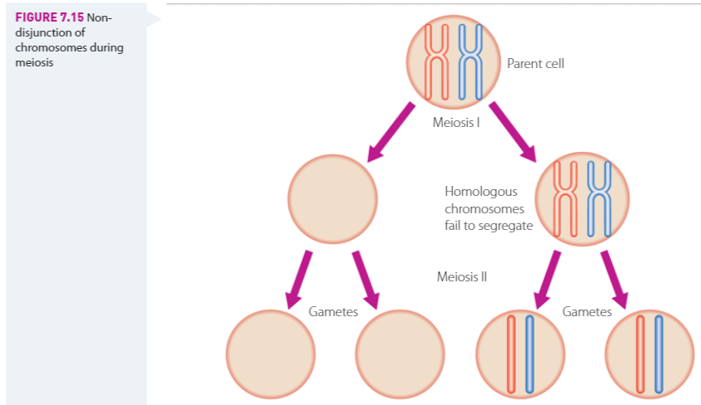

Investigation 7.3
Check your understanding 7.3 page 247

- evaluate the effect of mutation, gene flow and genetic drift on the gene pool of populations

- The genetic diversity of plants and animals is a result of global spread and each population adapting to its local environment.
- New alleles can be introduced into a population by a mutation, or through the movement of individuals between populations.
- For example, height in humans is not just tall or short as with Mendel’s the plants.
- In humans height is a polygenic (many genes) trait.
- Each gene for this trait has two or more alleles, hence, there are a large number of variants.
- Therefore, there are many possible genotypes and phenotypes.
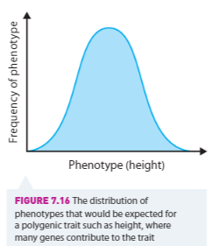

- Mutations affect phenotype which is the basis for natural selection. The following graph shows the affected of mutations of the fitness of individuals in a population.
- Few mutations overall are advantageous.
- Detrimental or deleterious mutations are eliminated, neutral mutations remain and those few that are beneficial are selected.
- Neutral mutations can be considered evolutionary in that they may provide an advantage in the future if the environment suddenly changes.

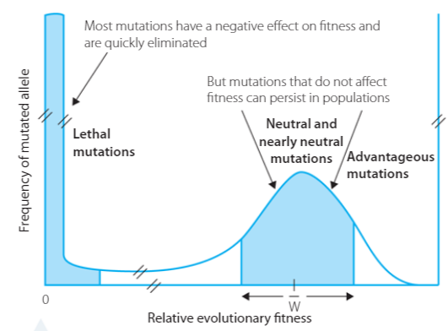
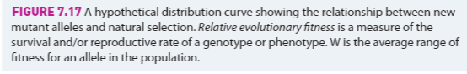

- Population genetics and factors causing changes in allele frequency.
- Population genetics is the study of how a population changes over time, leading to a species evolving.
- Natural selection is not the only factor that causes changes in the distribution of genetic variation in a population, resulting in that changing over time
- Sometimes individuals in a population are not selected by natural selection, but survive and reproduce by chance. For example, a natural disaster may strike in a particular place into wipe out some organisms. The allele frequency of the survivors will increase as they reproduce.
- This change in allele frequency due to chance is known as genetic drift.
- Allele frequency may also change when individuals leave or enter a population. This is known as a gene flow.

- Factors that cause changes in allele frequency within a population.
- Selective pressure causes changes in allele frequency due to variations - natural selection.
- Sexual selection (or non-random mating) changes allele frequency because mating is not random; the most successful mater’s genes remain in the gene pool.
- Mutation leads to the formation of new alleles, due to changes or errors in DNA that arise in gametogenesis. The good and the bad DNA are passed on to the next generation.
- Genetic drift causes changes in allele frequency due to random chance.
- Gene flow changes in allele frequency due to mixing of new individuals in a population.
- Genetic stability occurs if all individuals had the same reproductive capacity and fitness.

Investigation 7.4 Part A page 250
https://learn.genetics.utah.edu/content/selection/stickleback/

Check Your Understanding 7.4 p253

Biotechnology
Inquiry question: How do genetic techniques affect Earth’s biodiversity?

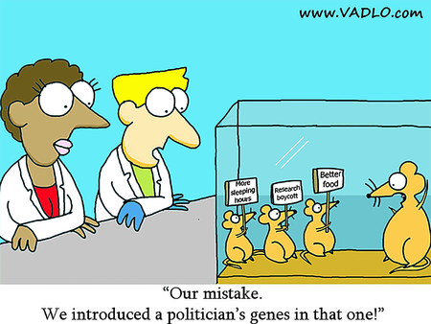

- investigate the uses and applications of biotechnology (past, present and future), including:

Students read pages 259 to 269 and do Investigation 8.1

  - analysing the social implications and ethical uses of biotechnology, including plant and animal examples

  - New technologies such as cloning and the CRISPR techniques (p275) allows very precise introduction of genes into cells, making it easier for scientists to alter the human and other genomes and combine the genes of different species.
  - This raises issues of human and animal rights and can directly impact on evolutionary pathways. Hence the need for controls and ethics in scientific research.
  - Human experimentation
- Ethical issues generally arise in relation to population groups that are vulnerable to abuse (children, racial groups …)
- Human participation requires voluntary, “educated”, informed consent…
- This sometimes can be a “fuzzy” area

- Experimentation on animals
- Animal experiments are widely used to develop new medicines and to test the safety of other products.
- Many of these experiments cause pain to the animals involved or reduce their quality of life in other ways.
- If it is morally wrong to cause animals to suffer then experimenting on animals produces serious moral problems.
- Animal experimenters agree that it's wrong to use animals if alternative testing methods would produce equally valid results.

- Biobanks
- A biobank is a type of biorepository that stores biological samples (usually human) for use in research
- Ethical issues could occur because of commercialisation, discrimination, informed consent, privacy of research participants, return of results, public consultation, resource sharing

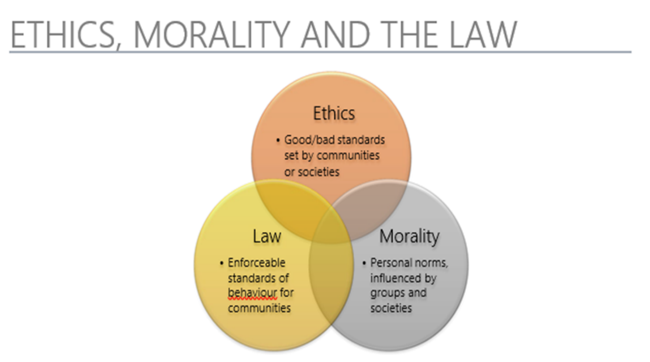

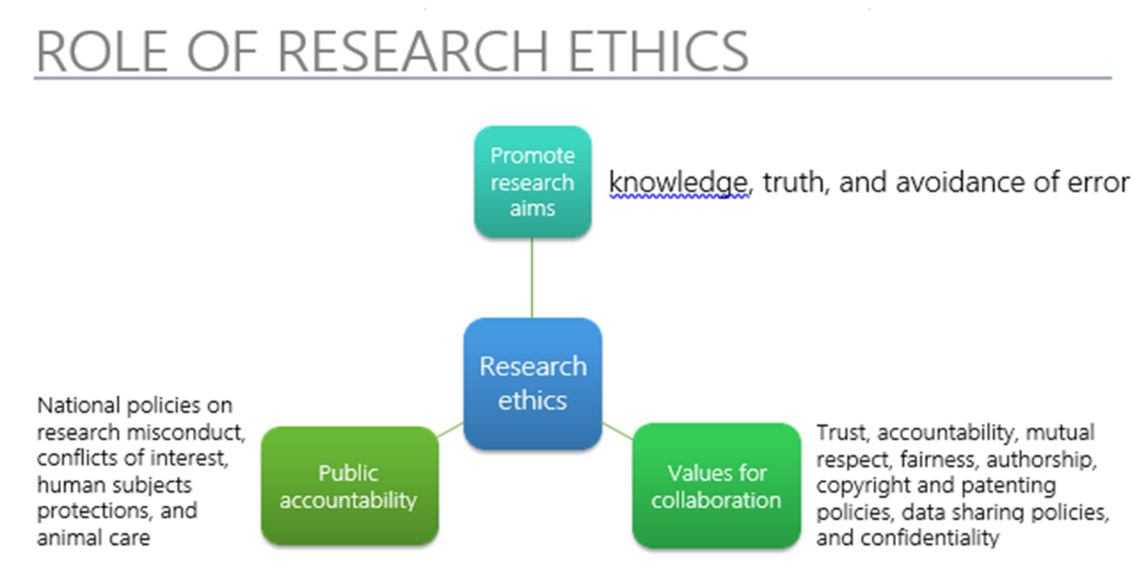

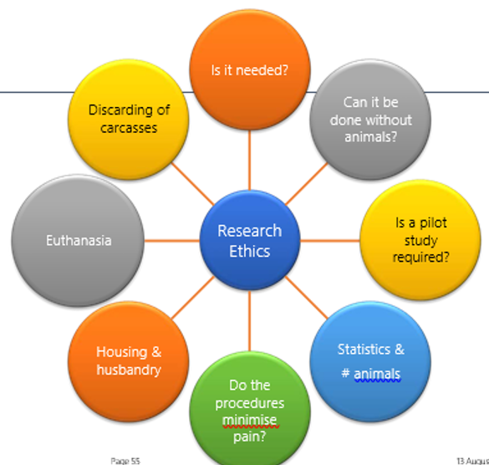

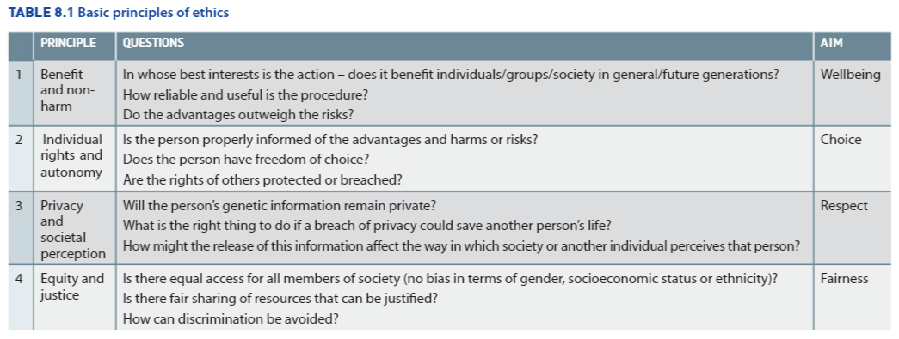

- Case study: Global need for increase in agricultural products.
- It has been estimated, that by the year 2050 year will be an additional 2.41 billion people in the world to feed. Most of these population increases are likely to come from less developed countries.
- The demand for food and other resources to sustain the population will grow exponentially and this puts new demands on the agricultural industry.
- Reproductive and genetic technologies in livestock and crop production can make a positive contribution in developing countries by alleviating poverty and hunger and reducing the occurrence of disease.
- When looking to increase food production the social and ethical implications of new biotechnologies need to be considered, these include:
- Medical and health benefits
- Financial and social justice issues
- Animal and human rights
- The effects on the environment

Check your understanding 8.2 page 275

  - researching future directions of the use of biotechnology
  - evaluating the potential benefits for society of research using genetic technologies

- As technology and its applications are constantly developing so are the advances in biotechnology.
- A recent development in biotechnology is a new genome editing technique called CRISPR (Clustered Regularly Interspaced Short Palindromic Repeats).
- The CRISPR enzymes were discovered in bacteria these enzymes chop up the DNA of invading viruses.
- CRISPR-Cas9 is an enzyme can be used to snip DNA at a particular base, so it can then be attached to a ‘guide’ RNA that targets a specific complementary nucleotide sequence in the genome to which it will be added.
- Hence, genes can now be spliced and inserted with pinpoint accuracy. This has the potential of opening up whole new areas in biotechnology.
- This technology could make it possible to uncover genes that are instrumental in causing neurological disorders such as Alzheimer’s disease and schizophrenia and then alter them.
- However, it does raise concerns about germ-line gene editing to produce designer babies. There are many ethical considerations in this application.

Investigation 8.3
https://cosmosmagazine.com/biology/aus-french-venture-boosts-wheat-fibre

  - evaluating the changes to the Earth’s biodiversity due to genetic techniques

- Changes to Earth’s biodiversity
- Biodiversity is critical in maintaining healthy ecosystems and hence, sustaining plant and animal life on earth.
- The importance of and the need to conserve diversity is universally recognized.
- With increasing biotechnology and the combining of what was once two distinct species, (the creation of transgenic species), biodiversity can be increased in the short term.
- However, biodiversity will be reduced if these organisms with desirable characteristics are reproduced and bred, using reproductive technologies such as cloning and selective breeding.
- Also the cross breeding of wild varieties of plants and animals with genetically engineered ones has the potential to affect Earth’s a diversity.
- A major disadvantage of biotechnologies such as selective breeding, cloning and genetic engineering is the potential to reduce genetic diversity in the long term.
- This increases the risk of populations being wiped out in response to a disease or a sudden environmental challenge.
- To overcome the threat of reduced diversity, stocks of a variety of plants and animals must be maintained to ensure continued biodiversity.

Read the following article:
https://www.nationalgeographic.com/magazine/2013/04/species-revival-bringing-back-extinct-animals/

Investigation 8.4 p 277

Genetic Technologies
Inquiry question: Does artificial manipulation of DNA have the potential to change populations forever?

- investigate the uses and advantages of current genetic technologies that induce genetic change
- compare the processes and outcomes of reproductive technologies, including but not limited to:
  - artificial insemination
  - artificial pollination

See notes in Module five

- investigate and assess the effectiveness of cloning, including but not limited to:
  - whole organism cloning

See notes in Module five

  - gene cloning
- Gene cloning is where the selected gene is removed from the source DNA and inserted into the DNA of another organism, to make identical copies of the gene. For example, this technique is used in the production of insulin on a large-scale.
- The simplified steps involved in the process of gene cloning are:
- The gene is cut from the source organism using restriction enzymes. These enzymes are produced by bacteria.
- The gene is pasted into a vector DNA or plasmid by a process known as ligation (Ligase enzymes are used to cut fragments of DNA).
- The plasmid containing the gene is introduced to a host cell by a process called transformation. (A plasmid is a genetic structure in a cell that can replicate independently of the chromosomes, typically a small circular DNA strand in the cytoplasm of a bacterium or protozoan.)
- The host cell can now make copies of the vector DNA when its makes copies of its own DNA.
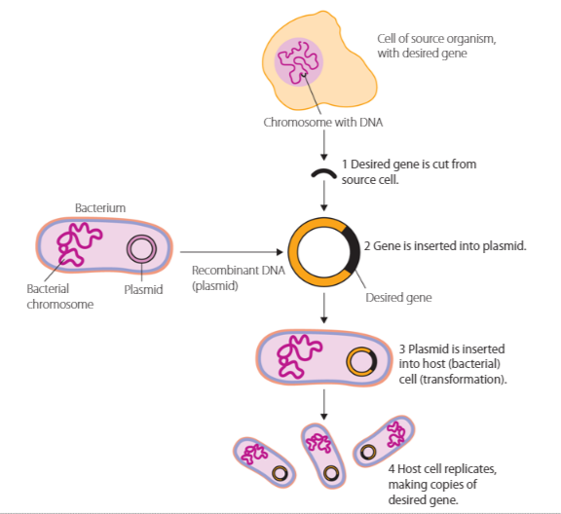

- Polymerase chain reaction (PCR)
- PCR is a form of in vitro DNA cloning which is widely used in research and has many genetic applications.
- It amplifies a particular DNA sequence and makes multiple copies.
- PCR involves a process of thermal cycling to denature the DNA strand and the use of complementary primers to locate and duplicate the required section of DNA.
- The three processes are denaturing, annealing and extension to make multiple copies of the segment of DNA.

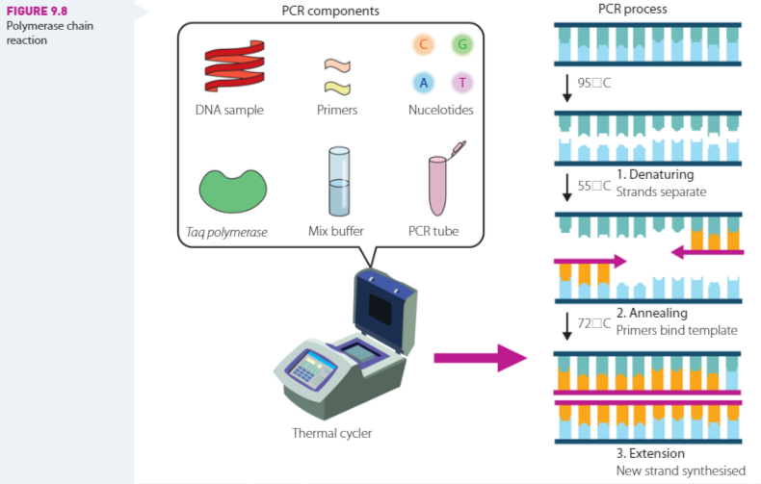

- describe techniques and applications used in recombinant DNA technology, for example:
Recombinant DNA Technologies
The process of recombinant DNA technology:
- The required to gene is isolated from a cell.
- A plasmid is removed from bacteria using a restriction enzymes
- Two pieces of DNA are cut using the same restriction enzyme.
- The fragments produced have matching sticky ends.
- The bacterial plasmid is cut at two points using the same restriction enzyme.
- As the sticky ends of the human gene and the plasmid come together, they joined up via base pairing. This process is called annealing.
- DNA fragments are joined by the enzyme DNA Ligase
- The plasmid is inserted back into the bacterial cell, where multiple copies of the gene can be produced.
- Once multiple copies of the gene have been produced, the gene can be inserted into an egg cell of another species and, after fertilisation, becomes part of the newly formed organisms DNA.
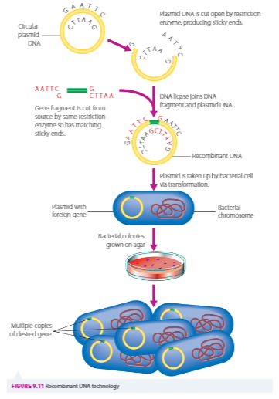

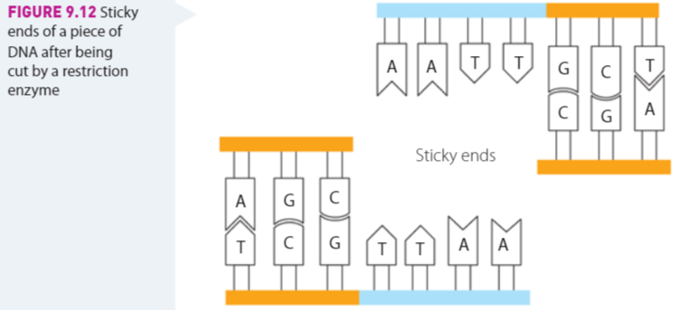

- Delivering the gene
- There are four main ways of inserting the desired gene into the genome of a species to be genetically transformed:
- Micro-injection of DNA directly into the nucleus of a single cell. This is usually done under an optical microscope.
- Biolistics is mechanically delivering DNA on microscopic particles into target tissues and cells by ‘firing’ them from a ‘gene gun’. For example tiny gold particles are used to coat the DNA, which is then fired at the target cells under high pressure or voltage.
- Electroporation – increasing the membrane permeability by applying an electric current.
- Transduction by a vector. DNA is carried into cells by a viral vector such as adenovirus, liposome or bacterial plasmid.
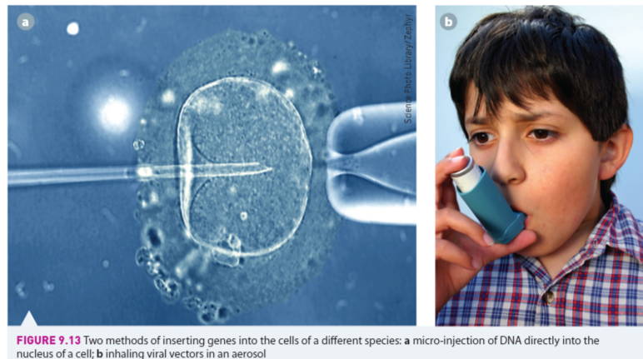
  - the development of transgenic organisms in agricultural and medical applications
- evaluate the benefits of using genetic technologies in agricultural, medical and industrial applications

Student research: present a word document that covers the above syllabus points that outlines the development of one transgenic plant, one animal, one medical and on industrial application.

- evaluate the effect on biodiversity of using biotechnology in agriculture
The effect of biotechnology on agriculture

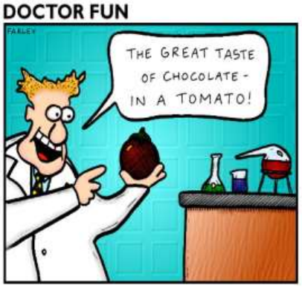

- Biotechnologies may increase or decrease the genetic diversity of species, depending on how they are used.
- Selective breeding has the potential to the increase and decrease genetic diversity.
- In the short term, introduced genes broaden the gene pool in a population.
- In the long term, if selected desirable genes constantly replace other varieties of genes, the gene pool, and therefore genetic diversity will decrease.
- For example:
- From Darwin’s work with the selective breeding of pigeons, he identified that the process of selection (natural or artificial) determines the success of an individual is reproducing and passing on its variations.
- This selection acts on the phenotype then determines which genotypes are passed on, directly affecting the gene pool.

Investigation 9.5

- interpret a range of secondary sources to assess the influence of social, economic and cultural contexts on a range of biotechnologies

Social context
- Biotechnological techniques that are available to a society are dictated by the specific needs of that society.
- Factors in this includes:
- Choices made by government
- Wealth of individuals
- Economic status of the country

- Economic context
- The cost of research and development in producing genetically modified (GM) foods can be extensive.
- This costs is passed on to farmers and consequently is passed on to consumers.
- Many GM products are patented. This allows multinational corporations to have a monopoly on products.
- GM food can be produced in greater volumes for the same or less cost. The potential here is that the Farmer receives a greater financial return and the consumer pays less.
- For example, the potential to produce GM Atlantic salmon in greater volumes them by natural means. This can learning a greater supply and a lower cost.
Investigation 9.6

